GADSDEN COUNTY



COMPREHENSIVE EMERGENCY
MANAGEMENT PLAN
Executive Summary

Gadsden County Government is dedicated to preserving and enhancing the quality of life in our community. By providing cost effective services, County government will promote orderly growth for the health and safety of its citizens.

The Gadsden County Sheriff’s Office of Emergency Management and the agencies that make up the Gadsden County Emergency Management Team are dedicated to saving lives and protecting property of residents and visitors from natural and man-made hazards. Gadsden County is vulnerable to a wide range of hazards including, among others, hurricanes, floods, tornadoes and hazardous materials incidents. Recognizing these vulnerabilities and its responsibility to protect the lives and property of residents and visitors, Gadsden County has developed a Comprehensive Emergency Management Plan (CEMP) to mitigate, prepare for, respond to and recover from emergency events that may impact the County.

The Gadsden County CEMP is authorized by Chapter 252 Florida Statutes, follows the National Incident Management System (NIMS) and is divided into three components: a Basic Plan, Recovery Element, and Mitigation Element and four (4) appendices (Maps, Standard Operating Guidelines, Emergency Support Functions and other plans). The Basic Plan provides a description of Gadsden County, including geographic, demographic, and hazard vulnerability information. Also included is the concept of operations used by the Gadsden County Emergency Management Team to guide all aspects of disaster management. This includes the direction and control under which emergency management activities are carried out; emergency notification and warning; response actions; agency responsibilities; financial management controls; training and exercises; and public awareness and education.

The Recovery Element provides an overview of disaster recovery operations in Gadsden County. The Gadsden County Office of Emergency Management has also developed standard operating guidelines for seven critical recovery functions. These recovery functions are Damage Assessment, Debris Removal, Community Relations, Unmet Needs, Emergency Housing, Disaster Recovery Centers and the Public Assistance Program.

The Mitigation Element provides guidance for both pre- and post-disaster mitigation opportunities. The Mitigation Element draws heavily on the Gadsden County Local Mitigation Strategy (LMS). The LMS includes an analysis of the hazards to which the county is vulnerable, the specific areas and resources that are at risk and suggested means of reducing threats to identified hazards.

The Gadsden County CEMP provides a general understanding of the County’s overall emergency management operation and each participating agency’s responsibilities for preparedness, response, recovery, and mitigation activities. The supporting procedures referenced throughout the Gadsden County CEMP provide additional details regarding disaster operations. In addition, each agency is responsible for developing their own procedures to guide their responses to a disaster. Agencies are encouraged to involve the Gadsden County Office of Emergency Management in the development of these procedures to insure continuity of disaster operations.

Table Contents

Executive Summary 1
Table of Contents 2-4

Basic Plan Section-Page
I. INTRODUCTION Basic, Page 5
A. Purpose Basic, Page 5
B. Scope Basic, Page 6
C. Methodology Basic, Page 6

II. SITUATION Basic, Page 7
A. Hazards Analysis Summary Basic, Page 7
B. Geographic Information Basic, Page 19
C. Demographics Basic, Page 20
D. Economic Profile Basic, Page 22
E. Planning Assumptions Basic, Page 23
F. Emergency Management Support Facilities Basic, Page 24

III. CONCEPT OF OPERATIONS Basic, Page 27
A. General Basic, Page 28
B. Emergency Management Operating Levels Basic, Page 29
C. Organization Basic, Page 30
D. Direction and Control Basic, Page 40
E. Notification and Warning Basic, Page 44
F. Preparedness Activities Basic, Page 45
G. Response Activities Basic, Page 48

IV. FINANCIAL MANAGEMENT Basic, Page 55

V. REFERENCES AND AUTHORITIES Basic, Page 57
A. County Responsibilities as Defined by Florida Statutes, Chapter 252 Basic, Page 57
B. Additional Florida Statutes Applicable to Local EM Programs Basic, Page 57
C. Florida Administrative Code Basic, Page 58
D. Plans and Procedures Related to the CEMP Basic, Page 58
E. Local Administrative Rules and Procedures Basic, Page 59
F. Other Supporting Documents Basic, Page 59
G. Mutual Aid Agreements Basic, Page 59
H. NIMS Compliance References Basic, Page 59

VI. ACRONYMS Basic, Page 59

VI. TERMS AND DEFINITIONS Basic, Page 60

Recovery Element Section-Page
I. INTRODUCTION RE, Page 2

II. GENERAL RE, Page 2
A. Responsibility for Recovery Operations RE, Page 2
B. Lead and Supporting Agencies for Recovery RE, Page 2
C. Concept of Operations RE, Page 4
D. Direction and Control RE, Page 8

Recovery Functions
Community Relations
Unmet Needs
Debris Management
Public Assistance Programs
Emergency Housing
Disaster Recovery Centers
Damage Assessment

Mitigation Element Section-Page
I. INTRODUCTION ME, Page 2

II. GENERAL ME, Page 2
A. Costs to Communities ME, Page 2
B. Costs to Local Government ME, Page 2
C. Lead Agency for Pre-Disaster and Post-Disaster Mitigation ME, Page 3
D. Support Agencies for Pre-Disaster and Post-Disaster Mitigation ME, Page 3
E. Concept of Operations ME, Page 3

III. PRE-DISASTER HAZARD MITIGATION ACTIVITIES ME, Page 6

IV. POST-DISASTER MITIGATION FUNCTIONS ME, Page 6
A. Planning Assumptions ME, Page 6
B. Lead Agency with Responsibility for Mitigation ME, Page 6
C. Local Agencies with Supporting Roles in Mitigation ME, Page 7
D. Roles and Responsibilities of Lead and Support Agencies ME, Page 7
E. Coordination Between Lead and Support Agencies ME, Page 8
F. Equipment and Resources Necessary for Mitigation Assessment ME, Page 8
G. Training Procedures for Mitigation Personnel ME, Page 8
I. BASIC PLAN INTRODUCTION

Gadsden County, hereafter referred to as the County, is exposed to many different types and levels of hazards. The required response to these hazards can vary from increased awareness of potential severe weather to large-scale evacuation and subsequent recovery from a major disaster. The wide variance in the number of agencies tasked and the actions to be taken by each under different conditions can lead to confusion and the misinterpretation of required actions. The Comprehensive Emergency Management Plan (CEMP) describes the basic strategies, assumptions, operational goals and objectives, and mechanisms through which the County will mobilize resources and conduct activities to guide and support emergency management efforts through preparedness, response, recovery, and mitigation.

A. Purpose

Chapter 252, Florida Statutes, requires every County in Florida to develop a CEMP. This plan establishes uniform policy and procedures consistent with the National Incident Management System (NIMS) for the effective coordination of resources to cope with a wide variety of natural, man-made and technological emergencies. The Gadsden County CEMP is operations-oriented and provides for a coordinated local response to all disasters. The Gadsden County CEMP was developed in accordance with the guidelines established by the Florida Division of Emergency Management (FDEM) and is consistent with the State of Florida CEMP.

The goals of the Gadsden County CEMP and the Gadsden County emergency management program are to:

- Preserve life, protect property and minimize disruptions in service that would adversely impact the quality of life for residents and visitors to Gadsden County Preparedness activities shall be conducted on an ongoing basis to ensure readiness for all types of emergencies. These activities include educational presentations, distribution of brochures, press releases, video presentations and pamphlets on the hazards in our community and on how to prepare, respond, recover, and mitigate loss of life and damage to property.

- Respond to emergencies using all available resources necessary to preserve the health, safety and welfare of persons affected by the emergency situation;

- Provide emergency relief and coordinate immediate and long-term recovery operations in areas affected by disasters; and

- Develop a systematic program to mitigate the effects of various natural and technological hazards.

B. Scope

The Gadsden County CEMP:

- Identifies the types of emergencies that are likely to occur in the County including minor, major and catastrophic disasters;

- Provides a concept of operations guiding the response, recovery and mitigation activities for all emergencies from the monitoring phase through long-term recovery;

- Defines the roles and responsibilities of primary and support agencies in Gadsden County to enhance their ability to effectively respond to emergency situations; and

- Provides for interagency coordination among local, state, federal and volunteer organizations to facilitate response and recovery activities.

C. Methodology

The Gadsden County Office of Emergency Management has prepared this document with guidance and assistance from each of the following organizations:

Exhibit 1.1: Agencies Participating in Gadsden CEMP Development
Gadsden County Board of Commissioners | Gadsden County Sheriff's Department
Gadsden County Community Planning | City of Chattahoochee (and associated departments)
Gadsden County Office of Emergency Management | City of Greensboro (and associated departments)
Gadsden County Emergency Medical Service | City of Gretna (and associated departments)
Gadsden County Planning and Zoning | City of Havana (and associated departments)
Gadsden County Public Health | City of Midway (and associated departments)
Gadsden County Property Appraiser | City of Quincy (and associated departments)
Gadsden County Public Works | Gadsden County Volunteer Fire Departments
Gadsden County Recycling and Animal Control | Capital Area Chapter of the American Red Cross
Gadsden County School Board

The Gadsden County CEMP was developed using widely accepted planning principles and practices in the field of emergency management and follows compliance criteria developed by FDEM. The plan incorporates information from many sources, which are noted throughout the document. Standard operating guidelines supporting this plan were developed in conjunction with primary agencies. Letters of support from primary agencies are on file and available from the Gadsden County Office of Emergency Management. The draft CEMP was distributed for review to agencies and individuals active in emergency management in Gadsden County. Maintaining the CEMP is an on-going process in which changes are periodically made to the plan by the County’s emergency management staff and distributed to Plan recipients for inclusion in their copy of the CEMP. Annually, or more frequently, if necessary, agencies tasked with primary response roles will review their standard operating guidelines to ensure that they accurately reflect response procedures during an emergency situation.

Preparedness is the responsibility of individual jurisdictions and includes coordinating various preparedness activities among all appropriate agencies within a jurisdiction as well as across jurisdictions and with private organizations. This coordination is effected by mechanisms that range from individuals to small committees to large standing organizations. These mechanisms are referred to as “preparedness organizations” in that they serve as ongoing forums for coordinating preparedness activities in advance of an incident. Preparedness organizations represent a wide variety of committees, planning groups and other organizations that meet regularly and coordinate with one another to ensure an appropriate focus on planning, training, equipment and other preparedness requirements within a jurisdiction and./or across jurisdictions. The needs of the jurisdiction involved will dictate how frequently such organization must conduct their business as well as how they are structured. When preparedness activities routinely need to be accomplished across jurisdictions, preparedness organization should be multi-jurisdictional. Preparedness organizations at all levels should:

- establish and coordinate emergency plans and protocols including public communication and awareness;
- integrate and coordinate emergency response activities in their jurisdictions
- establish standards, guidelines and protocols necessary to promote interoperability among member jurisdictions and agencies
- adopt standards, guidelines and protocols for providing resources to requesting organization including protocols for incident support organizations
- set priorities for resources and other requirements

Gadsden County is committed to working with their partners to ensure that the county is prepared and ready to respond to an incident that may affect its citizens.

II. SITUATION

This section of the CEMP describes the potential hazards, geographic characteristics, land use patterns and demographics of Gadsden County. It also outlines the levels of disasters and planning assumptions necessary for an effective response to and recovery from an emergency.

A. Hazard Analysis Summary

- High Risk Hazards
Those risks having a higher probability of occurrence, with loss of life and property damage.

- Hurricanes and Tropical Storms

Since 1851, 52 tropical cyclones passed within 50 statute miles of Gadsden County. Seven of these events occurred since 1990. Although the County is safe from storm surge, damage from high winds, tornadoes, and rain induced flooding (standing water, river and creek overflow) poses a significant threat for widespread destruction. The development of a hurricane can be described as follows:

- Tropical Depression. This is the formative stage of a hurricane; maximum sustained winds are less than 39 MPH.

- Tropical Storm. The maximum sustained winds for a tropical storm range from 39 MPH to less than 74 MPH.

- Hurricane. The maximum sustained winds for a hurricane are greater than 74 MPH.

The Saffir-Simpson scale categorizes hurricanes according to their wind speeds, as follows:

Exhibit 1.2: Saffir-Simpson Hurricane Scale
Saffir-Simpson Hurricane Scale
Category | Wind speed | Storm surge
 | mph | ft
 | (km/h) | (m)
5 | ≥156 | >18 (>5.5)
5 | (≥250) | >18 (>5.5)
4 | 131–155 | 13–18
4 | (210–249) | (4.0–5.5)
3 | 111–130 | 9–12
3 | (178–209) | (2.7–3.7)
2 | 96–110 | 6–8
2 | (154–177) | (1.8–2.4)
1 | 74–95 | 4–5
1 | (119–153) | (1.2–1.5)
Additional Classifications
Tropical | 39–73 | 0–3
storm | (63–117) | (0–0.9)
Tropical | 0–38 | 0
depression | (0–62) | 0
Source: National Oceanic and Atmospheric Administration (NOAA), 2006

Exhibit 1.3 below depicts the paths of tropical storms and hurricanes passing within 65 nautical miles of Gadsden County since 1960, while Exhibit 1.4 provides data describing tropical storms and hurricanes affecting Gadsden County since 1950.

Exhibit 1.3: Tropical Storms and Hurricanes
Passing Within 50 statute miles of Gadsden County 1851-2009

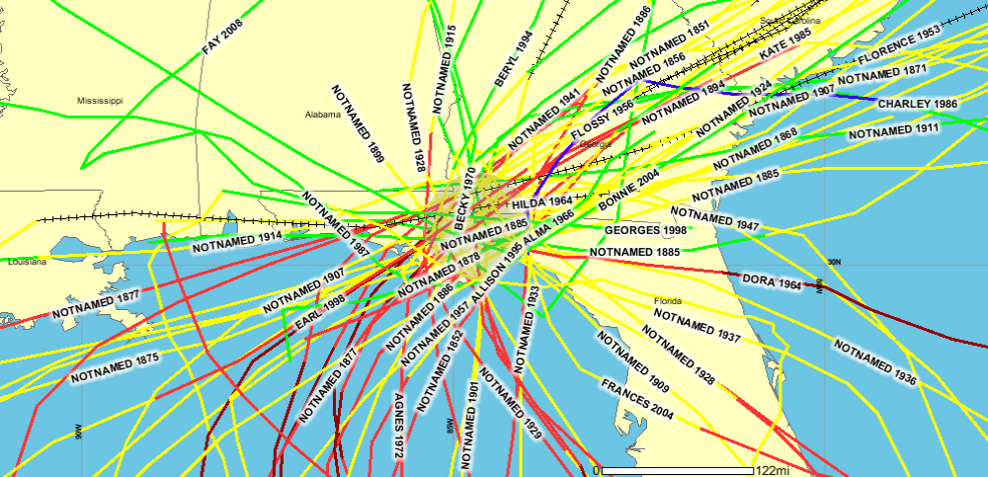
Exhibit 1.4
Date | Name | Category | Wind Speed of Storm (MPH)
August – September, 1964 | Dora | 1 | 90
June, 1965 | Unnamed | TS | 50
June, 1966 | Alma | 2 | 100
June, 1972 | Agnes | 1 | 75
November, 1985 | Kate | 2 | 100
August, 1994 | Beryl | TS | 60
June, 1995 | Allison | TS | 70
August – September, 1998 | Earl | 1 | 90
September, 1998 | George | TD | 35
September, 2000 | Helene | TS | 40
August, 2004 | Bonnie | TS | 50
September, 2004 | Frances | TS | 65
September, 2004 | Jeanne | TS | 45
July, 2005 | Dennis | TS | 40
October, 2005 | Tammy | TS | 40
August 2008 | Fay | TS | 45

Given the sheer size of tropical storms and hurricanes, the vulnerable zone consists of the entire County, especially those low-lying areas in the floodplain. The vulnerable population is 46,428, the entire population of the County.

- Flooding

Gadsden County is bounded by water on three sides: the Ochlockonee River to the east, the Apalachicola River to the west, and Lake Talquin to the south. Flooding is primarily the result of prolonged rain events typically associated with tropical weather systems. The County normally receives an average of 57” of rainfall per year with the majority of precipitation falling in June, July and August. Intense tropical events can produce 10-20” of rain falling in a 24-hour period of time.

Despite the abundance of major water features, Gadsden County historically has not been impacted by flooding to the same degree as neighboring counties. The primary reason is topography. Most of the landmass of the county sits on a plain above the aforementioned rivers and Lake Talquin. Also, the floodplain in Gadsden County is sparsely populated, so few people are in harm’s way in the event of a flood. There are two primary floodprone areas in the County: Crawfish Island and the area near Coonbottom.

Crawfish Island is a high area (relatively speaking) surrounded by low-lying Apalachicola River floodplain south of Chattahoochee. During prolonged rain events, the low-lying area floods and isolates approximately 30 homes in Crawfish Island. Exhibit 1.5 provides recent flooding information for the Apalachicola River.

Historical Crests
(1) 76.29 feet 07/10/1994
(2) 76.07 feet 03/12/1998
(3) 69.15 feet 04/01/2009

Exhibit 1.5: Jim Woodruff Dam Historical Crest Levels

The community of Coonbottom, located approximately 7 miles east of Havana on State Road 12 near the Ochlockonee River, can become isolated when the Ochlockonee River rises cutting off access to SR 12. Between 8 and 20 homes can be isolated depending on the depth of flooding. Flooding also routinely impacts a number of other roads including County Road 12 at the Ochlockonee River bridge. The population potentially affected by flooding is assumed to include all residents in the floodplain plus all residents affected by closures of roads and businesses. For planning purposes, this is assumed to be 25 percent of the county’s total population or 11,600 individuals.

l

Exhibit 1.6: 100-Year Flood Plain Map
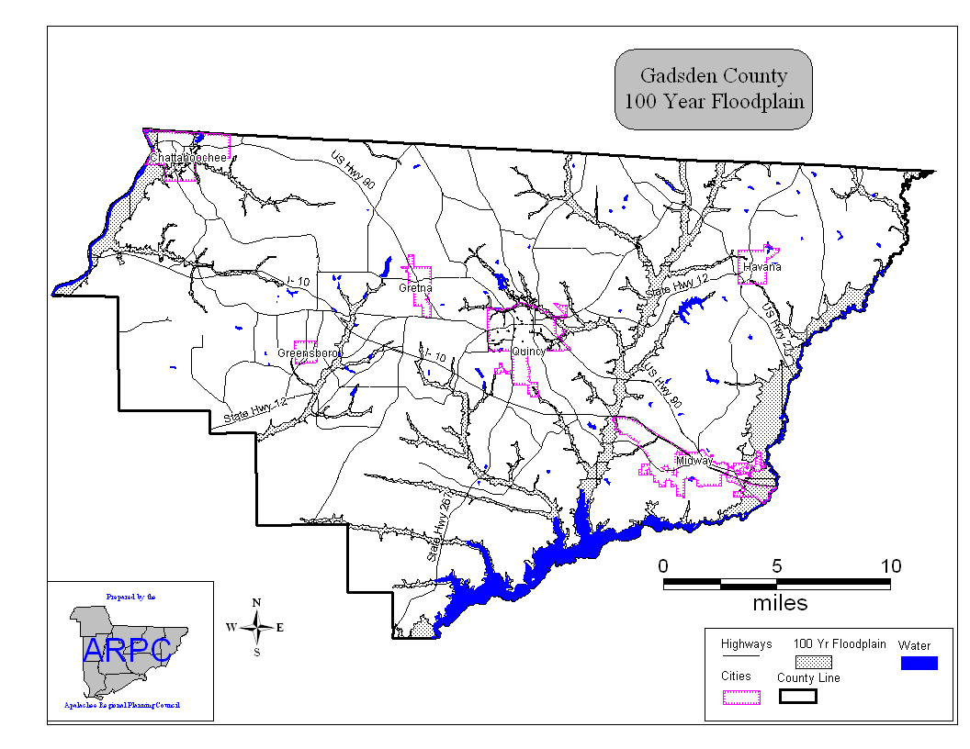

- Tornadoes/Severe Thunderstorms

The state of Florida ranks fourth nationally in the annual occurrence of tornadoes. The most active season is May through August with June being the peak month. Tornado strength is measured using the Fujita scale, which describes the estimated damage caused by a tornado as it passes over man-made structures (See description of the Fujita scale below).

Exhibit 1.7: Description of Tornado Ratings
OPERATIONAL EF SCALE
EF Number | 3 Second Gust (mph)
0 | 65-85
1 | 86-110
2 | 111-135
3 | 136-165
4 | 166-200
5 | Over 200
Source: National Oceanic and A Agency, http://www.spc.noaa.gov/faq/tornado/ef-scale.html

Between 1980 and 2005, a total of six tornadoes were reported in Gadsden County. The County has been affected by one strong F-2 tornado in 1995 which killed one person and injured another. Nearly $6 million in damages have been attributed to tornadoes in Gadsden County since 1980. Gadsden County residents living in older, poorly constructed or maintained manufactured housing and wood frame housing are especially at risk. The following table describes tornadoes that have occurred in Gadsden County since 1980.

Exhibit 1.8: Gadsden County
Tornado History (1980 - 2005)
Date | Magnitude | Deaths | Injuries | Property Damage ($)
11 Nov. 95 | F-1 | 0 | 0 | 0
19 Dec. 95 | F-2 | 1 | 1 | 30,000
19 Dec. 95 | F-1 | 0 | 0 | 20,000
16 Jan. 97 | F-1 | 0 | 0 | 1,000
24 Oct 97 | F-1 | 0 | 0 | 200,000
11 Mar. 00 | F-0 | 0 | 0 | 0
18 Feb 08 | F-1 | 0 | 1 | 200,000
04 Apr 09 | F-0 | 0 | 0 | 0
08 Apr 10 | F-0 | 0 | 0 | 0
Total |  | 1 | 6 | 451,000
Source: National Climate Data Center, 2006. http://www4.ncdc.noaa.gov/cgi-win/wwcgi.dll?wwevent~storms

- Hazardous Materials

(1) Fixed Facilities

There are 17 facilities in the County that store extremely hazardous substances (EHSs) above the minimum threshold planning quantity (TPQ) designated by the U.S. Environmental Protection Agency. Most of these sites store chlorine gas, which is used for disinfecting water. The County also has a number of facilities storing large quantities of pesticides and herbicides. Vulnerable zones for facilities storing hazardous chemicals range from 0.5 miles to 10.0 miles depending on the chemical and the quantity released. For additional information, consult the Gadsden County Fixed Facility Hazard Analyses in the EOC.

(2) Transportation of Hazardous Materials

Although most residents tend to focus on hazardous materials stored at facilities located near where they live, a significant quantity of hazardous chemicals are transported via road, rail, barge and pipeline. The primary road corridors used to transfer hazardous chemicals in and through Gadsden County include Interstate 10, US 90, US 27, and US 319. Data are not available describing hazardous commodities such as propane and gasoline which is also shipped on county and state roads in Gadsden County.

(a) Rail
CSX Transportation has a major rail line running east-west through Gadsden County, in or near the Cities of Chattahoochee, Midway and Quincy. A hazardous materials density study performed by CSX Transportation identified the top ten hazardous commodities transported by CSX in or through Gadsden County from September 1, 1998 to August 31, 1999. During this time period, 25,444 railcars of hazardous materials were transported over CSX tracks between Cottondale in Jackson County and Tallahassee in Leon County. Molten sulfur (5,011 rail cars), sodium hydroxide (3,228 rail cars), and liquefied petroleum gas (2,503 rail cars) were the three most frequently shipped commodities. Chlorine, sulfuric acid, and anhydrous ammonia are, respectfully, the ninth, twelfth and fourteenth most commonly transported hazardous materials between Cottondale and Tallahassee. Each of these three chemicals are classified as EHSs

(b) Barge
Hazardous chemicals are also shipped via barge on the Apalachicola River on Gadsden County’s western border. Data from the U.S. Army Corps of Engineers show that the most commonly shipped commodities are petroleum products including gasoline, fuel oil, asphalt, tar and pitch. Barge shipments on the Apalachicola River have recently been on the decline given lower water levels and the expense associated with this form of transport.

- Pipeline
Natural gas is transported through an underground pipeline operated by the Florida Gas Transmission Company. The pipeline runs in a generally east-west direction through the lower third of Gadsden County.

(d) Spills
According to data supplied by the Florida Division of Emergency Management, approximately 42 hazardous materials spills have been reported to the State Warning Point since 1995. Seventy-four percent of reported spills have been transportation related (highway, rail, barge or pipeline) and the vast majority of all reported spills have involved petroleum products.

(3) Hazardous Materials Response

Local resources available to respond to hazardous materials incidents are extremely limited. The County has only one paid fire department located in Quincy. The remainder of the county is served by volunteer fire departments. The nearest hazardous materials response team is the Tallahassee Fire Department. Given that hazardous materials are shipped in large volume via several means of transportation, it is prudent to assume that the entire population of the County (46,151) is vulnerable to this hazard.

2. Medium Risk Hazards
Those risks having a medium probability of occurrence, with a low probability to loss of life, or property.

- Brush/wildfires/forest fires

Due to Gadsden County’s rural nature, fires represent a significant hazard, particularly for persons living outside municipal boundaries. With more than 64 percent (approximately 29,500) of County residents living outside of incorporated areas, many in older, wood frame homes, wildfires are a significant concern. The County is served by one paid department (Quincy Fire Department) and eleven volunteer fire departments: Chattahoochee, Concord, Greensboro, Gretna, Havana, Midway, Mt. Pleasant, Robertsville, St. Johns, Sycamore, and Wetumpka. (See Fire Department Map, Exhibit 1.10).

Exhibit 1.10: Volunteer Fire Departments

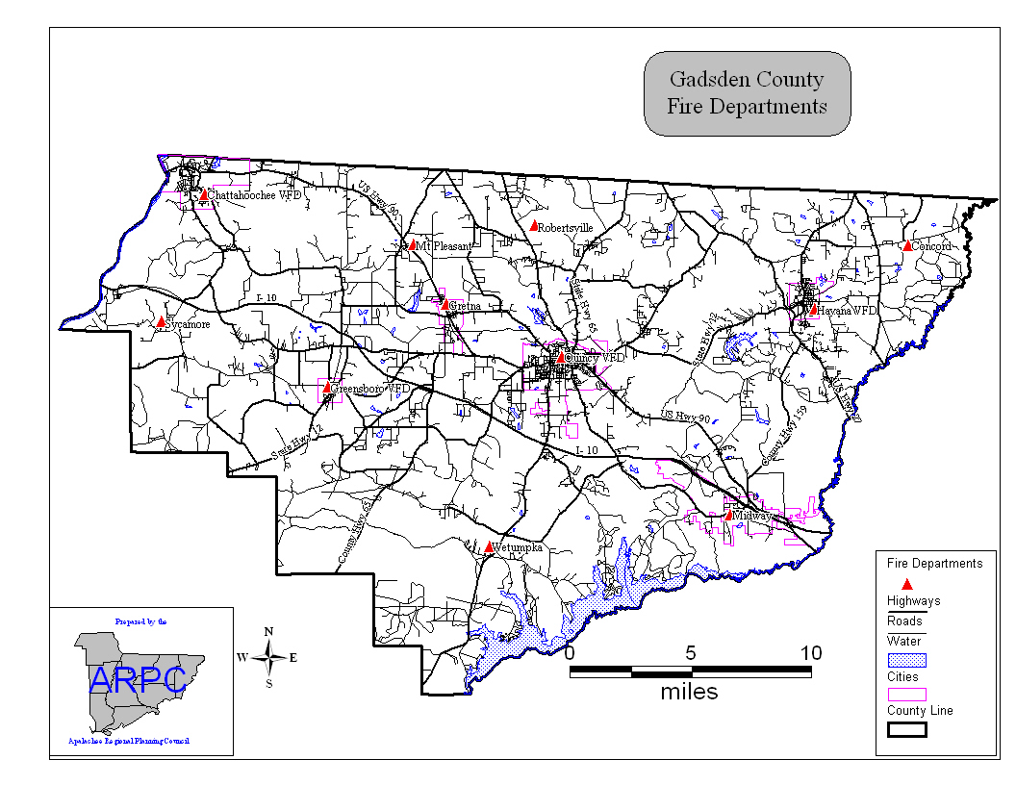

The Quincy Fire Department is under contract to respond to unincorporated Gadsden County to assist the volunteer fire departments in emergency response efforts. On an annual basis the Quincy Fire Department and the eleven volunteer fire departments responded to approximately 630 calls. These include responses to brush/woods fires, structure fires, vehicle accidents and vehicle fires. The majority of wild fires have been caused by debris burning that has gotten out of control. Those at greatest risk are residents in older wood frame housing or older manufactured housing, in remote, heavily wooded portions of the county. The approximate population at risk to this hazard is 29,500.

- Extreme Temperatures

Gadsden County is located in the northern portion of the state and a severe freeze can be expected once every 5 or so years. According to the local Farm Services Agency, the agricultural industry in Gadsden County has not suffered significant losses from freezes in recent years. The agricultural industry in Gadsden County contributes a large percentage to the local economy and is very susceptible to damage from a severe freeze. Extreme heat can also create dangerous conditions including drought and wildfires. These hazards are covered elsewhere in the hazard analysis. The County’s elderly population (6,507) and individuals living in residences without adequate heating or cooling are at greatest risk from prolonged periods of extreme temperatures. The total estimated population at risk to this hazard is 7,500

- Drought

During the most recent major drought which occurred from 1998 – 2001, approximately 42 residential wells near Sycamore and Greensboro dried up forcing residents to rely on bottled water for their personal needs. The County applied for federal disaster assistance, which provided funding to assist County residents in digging deeper private wells. Gadsden County Emergency Management staff believes the population vulnerable to this hazard is less than 1,000.

The drought also had an impact on the County’s agricultural base. The hardest hit crops were peanuts, corn, and hay. Other crops impacted by drought conditions include wheat, oats and soy beans. According to the local Farm Services Agency, the County’s tomato crops have not been significantly affected.

- Power Failure

Given the heavy tree cover and rural nature of the County, a power failure is a constant possibility. Based on local experience, however, most power failures are localized and power is restored fairly quickly. It is possible, and highly likely, that a major power failure affecting many of the County’s residents will occur in a major hurricane. Talquin Electric provides electricity to approximately 85 percent of the County while the remaining power needs are provided by Florida Power. The entire county (46,151) is at risk from a widespread power outage.

3. Low Risk Hazards
Those risks having a low probability of occurrence, with a very low probability to loss of life or property damage.

Terrorism

Terrorism is a violent act intended to coerce a government or civilian population in order to further a political or social objective. Given the events of September 11, 2001, it is no longer possible to say that any location in the United States does not have some level of risk for terrorist activity. Gadsden County has identified infrastructure and buildings that are viewed as potential targets for terrorist activity. However, given the rural nature of the county and the relative lack of high profile targets, it is more likely that the county could be indirectly affected as a result of its proximity to a more visible target, the State Capital in Tallahassee. The population potentially affected by an act of terrorism is dependent on the nature of the attack. A site specific incident at a large facility like the County Courthouse could affect 100 or more people. An attack involving a biological or nerve agent could affect significant portions of the County’s population. However, it is important to note that this is an extremely unlikely, low probability event.

- Civil Disturbance

The most recent incident of rioting took place in Quincy in 1969, a time when rioting was occurring in many cities throughout the country. There have been no recent incidents of civil disturbances within the County, and, under normal circumstances, civil disturbances are considered an extremely low probability event. However, there is always the possibility of disturbances in response to adverse social and/or economic conditions. A devastating disaster, such as a major hurricane, that displaces numerous residents and disrupts the provision of public services, could result in a civil disturbance.

- Dam Failure

The U.S. Army Corps of Engineers operates the Jim Woodruff Lock and Dam located in Gadsden County, north of Calhoun County, on the Apalachicola River. Located behind the Jim Woodruff Lock and Dam is Lake Seminole, which is created by the confluence of the Chattahoochee and Flint Rivers. The lock and dam is a multipurpose project for navigation, hydroelectric power production and related uses. The impoundment is maintained at approximately 77.5 feet above mean sea level, although there is some fluctuation for power production. There is no storage for flood control. The facility maintains a safety and emergency notification plan, and conducts annual dam safety training. There have been no safety and/or structural problems noted at the dam. In the event of a possible failure, facility officials would initiate the notification procedures, which include notifying Gadsden County Office of Emergency Management. However, given the facility’s safety record and recent flood experiences, the likelihood of failure is considered minimal. The population potentially affected is estimated to be approximately 500 persons residing in low-lying areas in the Apalachicola River floodplain.

- Nuclear/Radioactive Hazards

According to the Department of Health, Division of Radiological Control, there are four facilities actively using radioactive materials in small quantities in the county. These are typically companies involved in road construction using devices containing small quantities of radioactive materials used to measure compaction in newly paved roadbeds. Given the small amounts of radioactive materials used in these devices and controls that exist regulating the use of this equipment, there is very little risk associated with this potential hazard.

Although there is no history of nuclear incidents in Gadsden County, the Farley Nuclear Power Plant in Houston County, Alabama is within 50 miles of Gadsden County and could pose a threat in the unlikely event of a release. The northern third of the County, including the City of Chattahoochee is located in the 50-mile vulnerability zone of that plant. It is prudent to assume that the entire population of the County would be directly or indirectly affected should a major accident occur at the facility. Again, this is considered to be an extremely low-probability event.

- Sinkholes

The aquifer underlying Gadsden County has a thick confining layer that is not particularly conducive to the development of sinkholes. Therefore, the threat of sinkhole development is considered virtually nonexistent.

- Exotic Pests, Diseases and Pandemic Outbreaks

In 2005, 728 cases of equine encephalitis were reported in Florida, with two cases in Gadsden County, one human infection and one horse infection. There were 451 cases of West Nile virus reported statewide in 2005, with one case reported in Gadsden County. The Gadsden County Public Health Department and the Florida Department of Health, continuously monitor for the outbreak of disease and coordinate with the health care community and the Emergency Management Department to ensure that vital information is available to reduce health threats to the public.

B. Geographic Information

- Geographic Description

Gadsden County is a rural, landlocked county located in northwest Florida and bordered by Grady, Decatur, and Seminole Counties in Georgia and by Jackson, Liberty and Leon Counties in Florida. The County covers 528.5 square miles including 12.4 square miles of water (Bureau of Economic and Business Research (BEBR). The County is bordered by water on three sides: the Ochlockonee River to the east, the Apalachicola River to the west, and Lake Talquin to the south. The majority of the County rests on a fairly level plain above the Apalachicola River and the average elevation is approximately 185 feet. The average maximum temperatures in the County are 61 degrees F in January and 91 degrees F in July. The average minimum temperature is 40 degrees F in January and 71 in July. The average rainfall is approximately 57” annually with the majority falling in June, July and August.

- Topography

The terrain in Gadsden County is generally level, and includes many heavily forested upland and wetland areas. The central and northern portion of the county is generally flat and well-drained and includes the City of Quincy, the largest municipality in Gadsden County, and the City of Gretna. The southern portion of the County includes the heavily forested Robert Brent Wildlife Management Area, the Joe Budd Wildlife Management Area and the Lake Talquin State Recreation Area. This area is characterized by a number of intermittent creeks that feed into the Little River, the Ochlockonee River and Lake Talquin. The western portion of the County is bounded by the Apalachicola River and the Robert Brent Wildlife Management Area. This area is sparsely populated, heavily forested and includes many low-lying marshy areas. Eastern Gadsden County includes the Cities of Midway and Havana and a large low-lying portion of the Ochlockonee River floodplain. Of the nearly 338,000 acres in the County, approximately 38,000 (nine percent) are in the 100-year floodplain.

- Land Uses

The most common land use throughout the County is agriculture, accounting for approximately 64.5 percent of the County’s land area. An additional 6.5 percent of the forestlands are managed by large timber companies for silviculture operations. Less than 12 percent of the County is included in residential, commercial, and industrial land uses.
Exhibit 1.11: Existing Land Uses in Gadsden County
Existing Use | Unincorporated County | Chattahoochee | Gretna | Greensboro | Havana | Midway | Quincy
Residential | 15246 | 536 | 335 | 100 | 255 |  | 970
Commercial | 1021 | 34 | 10 | 3.3 | 38 |  | 212
Industrial | 993 |  | 111 | 1.4 | 6 |  | 146
Agricultural | 178644 | 1425 | 410 | 355 | 60 |  | 112
Recreation | 260 | 40 | 16 | 1.4 | 85 |  | 44
Conservation | 10 | 0
Public | 904 | 262 | 215 | 8.8 | 52 |  | 253
Vacant/undeveloped | 104522 | 742 |  | 17.7 | 589 |  | 2199
Mining | 2541 | 0
Historic | 15 | 0 |  | 4
Other |  | 438 | 103 | 153 | 115
TOTALS | 314201 | 3477 | 1200 | 645 | 1200 |  | 3936
C. Demographics

- Population

Exhibit 1.12 contains the estimated population figures from the U.S. Census Bureau most recent population estimates for Gadsden County. The majority of the population (64 percent) resides in the largely rural unincorporated County.

Exhibit 1.12: Population Data, 2010 Census
2010Total Population | 46,389
2011 Estimated Total Population | 46,151
 | 29,536 (64%) Unincorporated |  |  | 16,614 (36%) Incorporated
Density | 89.8 persons per square mile
Distribution by Age | 0-5 | 6-18 | 19-64 |  |  | 65+
 | 3,230 | 7,799 | 28,613 |  |  | 6,507
Distribution by Race | Black |  |  |  | White
 | 25,613 |  |  |  | 20,538
Special Needs Population | Mobility Impaired |  |  |  | Over 65
 | 350 |  |  |  | 6,507
Farm Workers | Appx. 3,300 seasonal and migrant workers at peak season. Migrant workers travel year round, seasonal maintain a residence in the county.
Areas of Large Tourist Population | Festivals include Quincyfest, Havana Music Festival
Non-English Speaking Population | Approximately 4,000 during peak agricultural season
Transient Populations | <At any one time there are an estimated 75 transient persons migrating through Gadsden County, many along the I-10 corridor
Manufactured home residents | Approximately 5,489 manufactured homes, approximately 16,467 residents
Inmate Population | Florida State Hospital – 1137 max, Gadsden Correctional Institute – 1,042 max, Quincy Correctional Institute – 408 max, River Junction Correctional – 736 max
Source: U.S. Census Bureau

- Population Vulnerable by Hazard

Exhibit 1.13 describes the population vulnerable to the natural and technological hazards that could affect Gadsden County. In most instances, the population vulnerable to these hazards is the entire population of the County. While it is unlikely that all of the County’s residents will be affected by any one event, the possibility does exist that any of the County’s residents could be affected by one of these hazards.

Exhibit 1.13: Vulnerable Populations by Hazard
 | Tropical Winds | Floods | Hazardous Materials  Spills | Nuclear Power Plant Incidents | Civil Disturbance | Extreme Temperature | Brush/Wild Fires/Forest Fires | Tornadoes | Drought | Terrorism | Infrastructure Disruption (Power Outage) | Dam Failure
Total Population | 46,151 | 12,500 | 46,491 | 46,151 |  | 7,500 | 33,000 | 46,151 | 1,000 | 46,491 | 46,151 | 500
Special Needs Pop. | 3 |  | 350 | 350 |  |  |  | 350 |  | 350 | 350
Farm Workers | 3,300 |  | 3,300 | 3,300 |  |  |  | 3,300 |  | 3,300 | 3,300
Tourist Pop. | 0 |  | 0 | 0 |  |  |  | 0 |  | 0 | 0
Non-English Speaking Pop. | <4,000 |  | <4,000 | <4,000 |  |  |  | <4,000 |  | <4,000 | <4,000
Transient Pop. | <75 |  | <75 | <75 |  |  |  | <75 |  | <75 | <75
Mobile Home Pop. | Apprx.  16,467 |  | Apprx.  16,467 | Apprx.  16,467 |  |  |  | Apprx.  16,467 |  | Apprx.  16,467 | Apprx.  16,467
Inmate Pop. | 3,323 |  | 3,323 | 3,323 |  |  |  | 3,323 |  | 3,323 | 3,323

D. Economic Profile

- Local Employment by Major Sector

The largest segment of the local economy in Gadsden County is government. Local, state and federal government employment including health care account for over thirty seven percent of total employment covered by unemployment compensation in Gadsden County. The majority of government employees work at the state level, many commuting to jobs in Tallahassee. The next largest sectors of employment include retail (10.0 percent), manufacturing (12.5 percent) and services 7.2 percent).

Exhibit 1.14: Average Monthly Private Employment
Covered by Unemployment Compensation Law in Gadsden County
Industry | Number of Employees | Percent of Labor Force
Ag, Forestry, Fishing | 2,001 | 3.5%
Construction | 706 | 9.1%
Manufacturing | 1,373 | 6.4%
Wholesale Trade | 349 | 2.4%
Retail Trade | 1,352 | 10.0%
Transportation and Warehousing | 224 | 4.5%
Information | 93 | 4.0%
Finance and Insurance Real Estate | 218 | 1.0%
Professional/Scientific/Technical Services/Administrative | 145 | 7.2%
Health Care and Social Assistance | 728 | 25.9%
Accommodation and Food Services | 372 | 5.5%
Other Services | 315 | 5.8%
Local, State & Federal Government | 5,394 | 15.9%
Total | 14,558 | 100.0
Source: 2010 Census

2. Unemployment

The unemployment rate in Gadsden County has gradually increased over the last several years from 4.0 percent in 2000 to 10.3 percent in 2011, the most recent year for which complete data are available. This reflects a similar increase in unemployment at the national level.
Exhibit 1.15:
Unemployment Rates 2000-2003
Year | Unemployment Rate
1990 | 5.1
2000 | 4.0
2010 | 10.7
2001 | 10.3

3. Income

Median household income in Gadsden County was $35,728 based on 2010 Census estimates. Per capita income was $16,843.

- Average Property Value

According to the Gadsden County Property Appraiser’s Office, the average property value in Gadsden County was $46,000.

5. Potential Economic Impact from Hazards

It is difficult to accurately quantify the potential impact to the local economy from the hazards identified previously. Clearly, there will be adverse consequences in terms of damage to public and private infrastructure, damage to businesses from closures, potential job losses across all sectors of the local economy, possible loss of personal income, potential disruption in the local tax base, and possible decline in property values in affected areas. However, losses will vary greatly for every event according to many variables. These include the type of event, duration of the event, magnitude of the event, and specific area impacted.

E. Planning Assumptions

The following assumptions have been used to assist the County in planning for a major emergency or disaster:

- A major emergency or disaster may overwhelm the ability of the County to provide traditional, prompt and effective emergency response and to implement short-term and long-term recovery measures.

2. The transportation infrastructure may be damaged and local transportation services may be disrupted which will impede normal movement and the movement required for response efforts.

3. Near-total disruption of energy sources and prolonged electric power failures may occur impeding the ability to respond and slowing the process of recovery.

4. Widespread damage to commercial telecommunications facilities may occur and the ability of governmental response and emergency response agencies to communicate may be impaired.

5. Homes, public buildings and other critical facilities and equipment may be destroyed or severely damaged.

6. Debris may make streets and highways impassable, seriously impeding the movement of emergency supplies and resources.

7. Public utilities may be damaged and be either fully or partially inoperable.

8. Many emergency personnel may be victims of the emergency, preventing them from performing their assigned emergency duties.

9. Numerous separate hazardous conditions and other emergencies could result from the major event, further complicating the response efforts.

10. Thousands of people may be forced from their homes and large numbers of people may be killed or injured.

11. Many victims may be in life-threatening situations requiring immediate rescue and medical care.

12. There may be shortages of a wide variety of supplies necessary for emergency survival.

13. Hospitals, nursing homes, pharmacies and other health/medical facilities may be severely damaged or destroyed; and the number of victims requiring medical attention may overwhelm those that do remain in operation.

14. Normal food processing and distribution capabilities may be severely damaged or destroyed.

15. Damage to fixed facilities that generate, produce, use, store or dispose of hazardous materials could result in the release of hazardous materials into the environment.

F. Emergency Management Support Facilities

- Critical Facilities

Critical facilities in Gadsden County include public buildings, water and wastewater treatment facilities, airfields, fire stations, police stations and critical private sector resources such as a radio station, hardware stores and other commercial businesses. A copy of the critical facility inventory is located at the Gadsden County EOC.

- Points of Distribution (PODs) and Staging Area

Three Type III PODs have been identified in Gadsden County for distributing essential items to the public, see the list below. In addition, if the county decides to open its own staging area, the Gretna Industrial Park will serve as the central staging area for Gadsden County. The Industrial Park, located on SR 12, is centrally located and has a large open field well suited for conducting staging operations. From the central staging area, resources will be transported to smaller staging areas established within each municipality. Please refer to the FDEM POD plan for more detailed information. The three Type III PODs are as follows:

- Chattahoochee
Florida State Hospital

- Gretna
Gretna Industrial Park

- Havana
Havana High School

- Landing Zones

The primary landing zone for the county is at the Quincy/Gadsden Airport located northeast of Quincy on State Road 12. The Quincy/Gadsden Airport has a paved 3,000 foot lighted runway, aircraft hangars and tiedowns. There are several other smaller airports in Gadsden County, however, none have paved runways. There are 31 designated landing zones for helicopters in the County. Each landing zone is described in a report located in the EOC entitled, “Helicopter Landing Zones for Medical Emergencies in Gadsden County”. The primary landing zone and primary staging area are shown on the accompanying map.

Exhibit 1.16: Gadsden County Landing Zones and Staging Areas

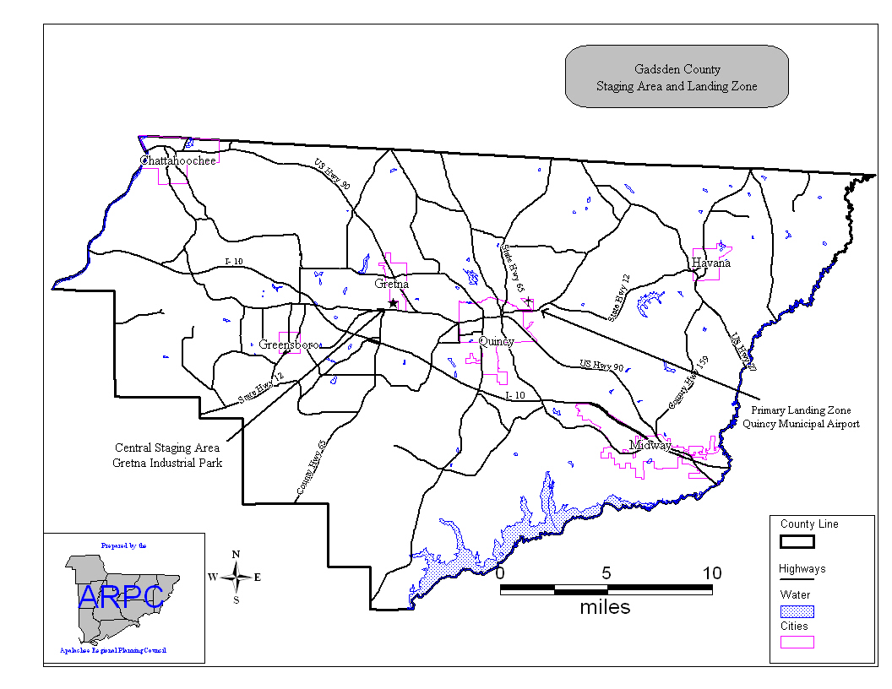

III. CONCEPT OF OPERATIONS

This section of the plan provides an overview of the operation of the Gadsden County Sheriff’s Office, Emergency Management Department. This section describes the methods for emergency management during preparedness, response, recovery, and mitigation.

A. General

- Description

Gadsden County is rural in nature, bordered by Jackson, Liberty and Leon counties in Florida and Grady, Decatur and Seminole counties in Georgia. There are six municipalities including: Chattahoochee, Greensboro, Gretna, Havana, Midway and Quincy. Each municipality maintains a police department and Gadsden County maintains a Sheriff’s Office in Quincy with jurisdiction countywide. Gadsden Community Hospital, located in Quincy is the only hospital in the County and is not currently functioning. The County has five Advanced Life Support EMS units on duty 24 hours a day, seven days a week and a total of ten ALS units in the fleet. EMS units are based out of Quincy, Havana and Chattahoochee. There is one paid fire department located in Quincy and eleven volunteer fire departments based in the following locations:

- Chattahoochee;
- Concord;
- Greensboro;
- Gretna;
- Havana;
- Midway;
- Mt. Pleasant;
- Robertsville;
- St. Johns
- Sycamore; and
- Wetumpka

The County operates a Public Works Department and a Planning and Zoning Department that serve the unincorporated area. The County has a Building Inspector who oversees issuing building permits and conducting inspections throughout the county as well as in municipalities that do not have their own inspectors. Chattahoochee, Gretna, Havana, and Quincy operate municipal public works departments and municipal water and sewer systems. Talquin Electric operates potable water systems in rural portions of the County. The Florida Department of Health maintains a County Public Health Unit in Quincy.

2. Relationship between Local Governments, State, and Federal Organizations

Historically, the incorporated municipalities, the unincorporated communities, and the County's constitutional government have jointly cooperated when disasters have impacted the County. The six municipalities and the County are signatories to the Statewide Mutual Aid Agreement and will lend whatever support they can to assist counties in need. The local governments strive to maintain a high level of cooperation and coordination with the State of Florida and the Federal government in terms of dealing with all aspects of emergency operations.

The National Response Framework (NRF), using the National Incident Management System (NIMS) and Unified Command (UC) will help to provide the framework for Federal interaction with State and local governments in the context of domestic incident prevention, preparedness and response and recovery activities.

3. Plan Activation

The Gadsden County Emergency Management Director is responsible for implementing the CEMP and activating the EOC. EOC activation includes partial or full-scale activation of Incident Command System Sections.

- Emergency Operations Center

The Gadsden County EOC serves as the central clearinghouse for information collection and coordination of response and recovery resources within the county. The EOC is located in the Gadsden County Sheriff’s Office at the W.A. Woodham Justice Center. The EOC is wind-rated for 160 mile per hour winds and is located in an area that is not prone to flooding. The EOC has a generator for emergency power. The alternate EOC is located at the county dispatch center at the Gadsden County Jail. The alternate EOC has phones, faxes, internet connection and a generator for back-up power.

- Requests for Assistance from Municipalities within Gadsden County

When a disaster strikes, municipalities request outside assistance through the County, specifically through the Gadsden County Emergency Management Department. The County then requests assistance from the Florida Division of Emergency Management through the State Emergency Operations Center during events that overwhelm local resource and response capabilities.

B. Emergency Management Operating Levels

The Gadsden County Emergency Management Department has three operating levels which are as follows:

- Level 1 – Full Scale Activation

In a full scale activation, all lead and support agencies are notified of a disaster. The EOC is activated on a 24-hour basis and staffed by all necessary personnel. All emergency management staff are available for disaster operations. Outside assistance from state and federal agencies will be needed.

- Level 2 – Partial Activation

This is a limited activation to a disaster. A partial activation may require 24-hour staffing from Gadsden County emergency management personnel and responding ESF personnel. It is possible that a partial activation may exceed local capabilities and require a broad range of state assistance.

- Level 3 – Monitoring

This is a monitoring phase. Notification will be made to agencies that need to take action as part of their everyday responsibilities. The EOC is not activated and EM staff are on duty during normal business hours (8:00 AM – 4:30 PM).

C. Organization

1. Normal (Non-emergency) Management Structure

The Gadsden County Board of County Commissioners (BOCC) is responsible for making decisions regarding the day-to-day governance of the County. Exhibit 1.17 describes the relationships among various County departments and agencies. Responsibility for emergency management activities resides within the Gadsden County Sheriff’s Office, at the Gadsden County Office of Emergency Management. The EM Department is responsible for emergency preparedness, response, recovery and mitigation activities throughout Gadsden County.

Exhibit 1.17 Normal Government Structure

Gadsden County Sheriff’s Office
Board of County Commissioners
County Manager
Office of Management
& Budget
Department of
Public Works
Assistant County
Manager
Emergency Medical
Services

Department of
Management Services
Growth
Management

Community Development
County Extension Services

Probation Department

Department of
Library Services

Gadsden County Board of County Commissioners
Organizational Chart
Solid Waste
Recycling
Office of Public
Information
Emergency Management
County Attorney
Health Department
Tourism Development Council
County Auditor
2. Emergency Management Organization System Used During Emergencies

The Incident Command System (ICS) is the organizational structure used in Gadsden County during emergency situations. This system allows for multi-agency coordination. Within the multi-agency coordination system, Emergency Operations Centers represents a physical location at which the coordination of information and resources that are used to support the incident and management activities takes place. Though an Incident Command Post (ICP) may begin with EOC responsibilities at the beginning of an incident, for long-term support an EOC will be activated.

The County’s EOC is organized by function. The EOC, though not necessarily mirrored against the field operations organizational structure, is still responsible for communicating between the Incident Commander (IC) or Unified Commander (UC), and/or with other EOCs.

The County’s incident management responsibility is supported through the Gadsden County Emergency Management Department. As a multi-agency coordination entity, the EM Department is responsible for, along with the EOC:

- Ensuring that each agency involved in incident management activities is providing appropriate situational awareness and resource status information;

- Establishing priorities between incidents and/or in concert with the IC or UC(s) involved;

- Acquiring and allocating resources required by incident management personnel in concert with the priorities established by the IC or UC;

- Anticipating and identifying future resource requirements;

- Coordinating and resolving policy issues arising from the incident(s); and,

- Providing strategic coordination as required.

Agencies involved in responding to the incident will be organized into four sections depending upon the needs of the incident: Operations, Planning, Logistics and Administration/Finance. In Gadsden County, the Operations Section involves the agencies where the majority of the county assets are housed. For this reason, the Operations Section can be broken down into one or more branches supervised by a branch coordinator who, in a major event, would coordinate the actions of the units within the section and serve as liaison with the Incident Commander. For example, the Quincy Fire Department is the lead agency charged with coordinating the response to hazardous materials incidents while the Sheriff’s Office is the lead agency responsible for coordinating the response to search and rescue incidents.

The lead agency responsible for operational aspects of disaster response will vary according to the type of incident. Regardless of the type of incident, the Gadsden County EM Director or Designee will serve as the overall Incident Commander within the EOC. The EM Coordinator and Administrative Assistant will assist the EM Director or Designee. Additional EM support personnel are available from the Gadsden County Sheriff’s Office and will be called upon if necessary.

- Response Activities

The EM Director or Designee has the primary responsibility for coordinating disaster response operations in Gadsden County. Exhibit 1.18 depicts the Incident Command System used during emergency response operations.

(1) Operations Section

The Operations Section plays a major role during the response phase of an emergency. During major disasters, the Operations Section of the Gadsden County ICS may be divided into as many as three operational branches, Emergency Response, Human Needs and Infrastructure. Coordinating agencies for these branches are, respectively, the Gadsden County Sheriff’s Office, the American Red Cross and the Gadsden County Public Works Department. Branch coordinators will be appointed at the discretion of the Incident Commander based upon the scope of the incident. Incidents of limited scope will not require the activation of all branches. These three branches are staffed by seven local agencies with responsibility for 14 ESFs. Exhibit 1.18 describes the agencies and responsibilities of the Operations Section.

Exhibit 1.18 Response Organizational Chart

Board of County Commissioners
Incident Command:
Emergency Management Coordinator
Operations Section
Finance/Admin.
Section
Logistics Section
Planning Section
Emergency Response Branch
(Sheriff’s Office Coordinator)

Gadsden Sheriff’s Office
Communications (ESF 2)
Military Support (ESF 13)
Law Enforcement (ESF 16)
Quincy F.D. & VFDs
Firefighting (ESF 4)
Search & Rescue (ESF 9)
Haz Mat (ESF 10)
County Public Health Dept.
Health & Medical (ESF 8)
Animal Control Dept.
Animal Protection (ESF 17)
Human Needs Branch
(Red Cross Coordinator)
Mass Care (ESF 6)
Food & Water (ESF 11)
Volunteers & Donations (ESF 15)

Infrastructure Branch
(Gadsden PW Coordinator)

Gadsden Public Works Dept.
Public Works (ESF 3)

Gadsden School Board
Transportation (ESF 1)
Emergency Management
Planning & Information (ESF 5)
Business Continuity (ESF 18)
Emergency Management
Resource Support (ESF 7)
Municipalities
Public Information (ESF 14)
ESF Reference List

ESF 1 Transportation
ESF 2 Communications
ESF 3 Public Works
ESF 4 Fire Fighting
ESF 5 Info and Planning
ESF 6 Mass Care
ESF 7 Resource Support
ESF 8 Health and Medical
ESF 9 Search and Rescue
ESF 10 Hazardous Materials
ESF 11 Food and Water
ESF 12 Energy
ESF 13 Military Support
ESF 14 Public Information
ESF 15 Volunteer and Donations
ESF 16 Law Enforcement
ESF 17 Animal Protection
ESF 18 Business Continuity
Gadsden Emergency Management
Energy Continuity (ESF 12)
Gadsden Clerk’s Office
(1) Planning Section

The Planning Section (ESF 5) is responsible for coordinating planning activities during an emergency event. The EM Department staffs the Planning Section. Given the limited personnel resources in Gadsden County, the individual tasked with disaster-related planning activities will likely have other responsibilities as well (e.g. coordinating the Logistics Section). Should additional staffing be required, personnel from the Gadsden Sheriffs Office are available to serve in this Section.

- Logistics Section

The Logistics Section is responsible for obtaining logistical support (ESF 7) for all lead and supporting agencies during all phases of disaster operations. This includes obtaining the equipment and personnel resources required to address local needs from public, private, and not for profit organizations. This section is staffed by the EM Department. The Gadsden County Chamber of Commerce will provide assistance by serving as a liaison with the business community. Should additional staffing be required, personnel from the Gadsden Sheriffs Office are available to serve in this Section.

- Administration and Finance Section

The Administration and Finance Section is staffed by the Clerk of the Court and is responsible for tracking expenditures, reimbursement, and general administrative support.

- Lead and Support Agencies for Response Operations

Lead and support agencies for response activities are described in Exhibit 1.19. Given the rural nature of Gadsden County, it is common for one agency to be responsible for several functions. For example, the Gadsden County Sheriff’s Office has primary responsibility for coordinating law enforcement and security activities (ESF 16), maintaining communications systems (ESF 2), conducting search and rescue operations (ESF 9) and coordinating with the Florida National Guard (ESF 13). The Sheriff’s Office also plays a supporting role for several agencies during response and recovery operations.

Similarly, the EM Department is responsible for coordinating multiple tasks during a disaster including providing information and planning support (ESF 5), resource support (ESF 7) and public information (ESF 14). Additional information describing agency responsibilities is provided in each agency’s EOC procedures available from the GCDEM.
Exhibit 1.19: Agency Responsibilities in the Response Phase for Major Events
 | ESF 1 | ESF 2 | ESF 3 | ESF 4 | ESF 5 | ESF 6 | ESF 7 | ESF 8 | ESF 9 | ESF 10 | ESF 11 | ESF 12 | ESF 13 | ESF 14 | ESF 15 | ESF 16 | ESF 17 | ESF 18
American Red Cross |  |  |  |  |  | P |  | S |  |  | P |  |  |  | P
Bell South |  | S
Big Bend Transit | S
Florida Power |  |  |  |  |  |  |  |  |  |  |  | S
Gadsden Recycling |  |  |  |  |  |  |  |  |  |  |  |  |  |  |  |  | P
Gadsden Clerk of the Court | S | S | S | S | S | S | S | S | S | S | S | S | S | S | S | S | S
Gadsden Emergency Mngt. | S | S | S | S | P | S | P |  | S | S | S | P | S | P | S |  |  | P
Gadsden EMS |  |  |  |  |  |  |  | S
Gadsden Public Health Dept. |  |  |  |  |  |  |  | P |  | S
Gadsden Public Works Dept. | S |  | P | S
Gadsden School Board | P |  |  |  |  | S
Gadsden Sheriff’s Office |  | P |  | S | S | S | S |  | P | S |  |  | P | S |  | P
Gadsden Community Hospital |  |  |  |  |  |  |  | S |  | S
GT Com |  | S
Humane Society |  |  |  |  |  |  |  |  |  |  |  |  |  |  |  |  | S
Municipal Police Departments |  | S |  | S |  | S |  |  | S | S |  |  |  | S |  | S
Municipal Road Departments |  |  | S
Municipal Water and Sewer Dept. |  |  | S
National Guard |  |  |  |  |  |  |  |  |  |  |  |  | S
Salvation Army |  |  |  |  |  | S |  |  |  |  | S
Sprint |  | S
Talquin Electric |  |  |  |  |  |  |  |  |  |  |  | S
TDS Telecom |  | S
Volunteer Fire Departments |  |  | S | P |  |  |  |  | S | S
P = Primary Agency
S = Support Agency

ESF 1 - Transportation
ESF 2 - Communications
ESF 3 - Public Works and Engineering
ESF 4 - Firefighting
ESF 5 - Planning
ESF 6 - Mass Care
ESF 7 - Logistics
ESF 8 - Health and Medical
ESF 9 - Search and Rescue
ESF 10 - Hazardous Materials
ESF 11 - Food and Water
ESF 12 - Energy
ESF 13 - Military Affairs
ESF 14 - Public Information
ESF 15 - Volunteers and Donations
ESF 16 - Law Enforcement
ESF 17 - Animal Issues
ESF 18 - Business

- Recovery Activities

The EM Director or his designee has the primary responsibility for coordinating disaster recovery operations in Gadsden County. The Incident Command System is the operational system used to manage recovery operations following a disaster. Exhibit 1.20 depicts the ICS used during recovery operations in Gadsden County.

(1) Operations Section

The Operations Section of the ICS maintains responsibility for nearly all aspects of post-disaster recovery operations. Three agencies, the Gadsden County Emergency Management Department, the Gadsden County Public Works Department and the American Red Cross, staff the Operations Section during recovery operations. The EM Department is responsible for coordinating damage assessment, establishing disaster recovery centers and coordinating participation in the Public Assistance Program. The Public Works Department is responsible for coordinating debris removal operations. The American Red Cross is responsible for coordinating community relations, unmet needs and emergency housing. Each of these activities is described in greater detail in the Gadsden County CEMP Recovery Annex and in the accompanying recovery standard operating guidelines.

- Planning, Logistics and Finance Sections

As noted above, the vast majority of recovery functions are carried out by agencies in the Operations Section of the ICS. The Planning and Logistics Sections are staffed by the Gadsden EM Department and are responsible for ESFs 5 and 7. The Gadsden County Clerk’s Office is responsible for coordinating financial management for recovery operations.

- Lead and Support Agencies for Recovery Operations

Lead and support agencies for recovery operations in Gadsden County are described in Exhibit 1.21. The EM Department is responsible for several tasks during recovery operations including coordinating damage assessment, establishing disaster recovery centers and coordinating participation in the public assistance program. The Gadsden County Public Works Department is responsible for coordinating debris removal operations, in conjunction with a private sector contractor. The Capital Area Chapter of the American Red Cross is responsible for coordinating community relations, unmet needs and emergency housing for disaster victims. Additional information describing agency responsibilities is provided in each agency’s EOC procedures available from the EM Department.
Insert Exhibit 1.20: ICS Recovery Chart
ICS Recovery Phase Org Chart

Board of County Commissioners
Incident Command:
Emergency Management Coordinator
Operations Section
Finance/Admin.
Section
Logistics Section
Planning Section
Emergency Management
(Sheriff’s Office Coordinator)

Damage Assessment
Disaster Recovery Centers
Community Relations
Unmet Needs
American Red Cross
Gadsden Public Works Dept.
Debris Removal

Emergency Management
Planning & Information (ESF 5)
Business Continuity
(ESF 18)
Emergency Management
Resource Support (ESF 7)
Municipalities
Public Information (ESF 14)
ESF Reference List

ESF 1 Transportation
ESF 2 Communications
ESF 3 Public Works
ESF 4 Fire Fighting
ESF 5 Info and Planning
ESF 6 Mass Care
ESF 7 Resource Support
ESF 8 Health and Medical
ESF 9 Search and Rescue
ESF 10 Hazardous Materials
ESF 11 Food and Water
ESF 12 Energy
ESF 13 Military Support
ESF 14 Public Information
ESF 15 Volunteer and Donations
ESF 16 Law Enforcement
ESF 17 Animal Protection
ESF 18 Business Continuity
American Red Cross
Mass Care
Gadsden Clerk’s Office

Exhibit 1.21: Agency Responsibilities in the Recovery Phase for Major Events
 | Damage Assessment | Debris Removal | Information  & Planning | Resource Support | Community Relations | Unmet Needs | Emergency Housing | Disaster Recovery Centers | Public Assistance  Program | Business Continuity
American Red Cross | S |  |  | S | P | P | P | S
Bell South | S
Florida Power | S
Gadsden Recycling |  |  |  |  |  |  |  |  | S
Gadsden County Churches |  |  |  |  |  | S
Gadsden County Chamber of Commerce |  |  |  |  |  |  |  |  |  | S
Gadsden Clerk of the Court | S | S | S | S |  | S | S | S | S
Gadsden Emergency Mngt. | S | S | P | P | S | S | S | P | P | P
Gadsden EMS
Gadsden Planning Department | S |  |  |  |  |  |  |  | S
Gadsden Property Appraiser | P
Gadsden Public Works Department | S | P |  |  |  |  |  |  | S
Gadsden School Board |  |  |  |  |  |  | S
GT Com | S
Municipal Police Departments
Municipal Road and Bridge Departments | S | S |  |  |  |  |  |  | S
Municipal Water and Sewer Departments | S |  |  |  |  |  |  |  | S
Salvation Army |  |  |  |  |  | S
Senior Citizen’s Association
Sheriff’s Office |  |  | S | S
Sprint | S
Talquin Electric | S
TDS Telecom | S
Volunteer Fire Departments | S | S |  | S |  |  |  | S
P = Primary Agency
S = Support Agency
c. Mitigation Activities

Mitigation planning in Gadsden County is the responsibility of the Gadsden County EM Department. The management system employed during mitigation activities is streamlined because Emergency Management has the primary responsibility for nearly all aspects of pre- and post-disaster mitigation. Although there are times when the EM Department receives assistance from supporting agencies, the vast majority of mitigation activities are carried out directly by Emergency Management staff. Exhibit 1.22 shows the relationship between the GCDEM and supporting agencies involved in mitigation operations. Additional information describing mitigation can be found in the Mitigation Element of the CEMP.

Exhibit 1.22: Agency Responsibilities for Hazard Mitigation
 | Pre-Disaster Mitigation | Post-Disaster Mitigation
American Red Cross | S | S
Florida Power | S | S
Gadsden Recycling | S | S
Gadsden Clerk of the Court | S | S
Gadsden Emergency Mngt. | P | P
Gadsden County Planning Dept. | S | S
Gadsden EMS | S | S
Gadsden Public Health Dept. | S | S
Gadsden Public Works Dept. | S | S
Gadsden School Board | S | S
Gadsden Sheriff’s Office | S | S
Gadsden Community Hospital | S | S
GT Com | S | S
Municipal Police Departments | S | S
Municipal Road Departments | S | S
Municipal Water and Sewer Depts. | S | S
National Guard | S | S
Salvation Army | S | S
Talquin Electric | S | S
Volunteer Fire Departments | S | S
P = Primary Agency
S = Support Agency

D. Direction and Control

- Overall Responsibility for Emergency Management Operations

Overall responsibility for all emergency management operations in Gadsden County, regardless of the type of incident, rests with the Emergency Management Director or his designee. Similarly, commitment authority for local assets is retained by the Emergency Management Director or designee. It is important to note however, that on-scene incident command responsibilities will be handled by the senior responder or most qualified responder on-site for all incidents. In most cases, this will be a representative of law enforcement, volunteer fire services or emergency medical services.

- Line of Succession

Gadsden County has established a line of succession to ensure continuous leadership during emergency situations. The line of succession is as follows:

Exhibit 1.23: Line of Succession by Organization
Organization | Primary | Secondary | Tertiary
County Commission | Chair | Vice Chair | Commissioners in order of seniority
County Administration | County Administrator
Emergency Management | EM Director | EM Coordinator | 911 Coordinator

Contact information for these individuals is available in the Gadsden County EM Notification Directory.

- Preparation of Local State of Emergency Proclamation

A template for the Local State of Emergency (LSE) proclamation is located in the County Administrator’s Office. Upon notification by the EM Department, the County Administrator’s Office will prepare the LSE proclamation and submit it to the Board of County Commissioners for consideration. The LSE proclamation provides authority for local governments to engage in a variety of necessary activities. These activities may include:

a. Performing public work and taking whatever action is necessary to ensure the health, safety, and welfare of residents and visitors to the County;

b. Entering into contracts and or purchase orders;

c. Employing permanent and temporary workers;

d. Utilizing volunteer workers;

e. Renting equipment;

f. Acquiring and distributing, with or without immediate compensation supplies, materials and facilities; and

g. Appropriating and expending public funds.

- Activation of the EOC

The EOC will be activated at the discretion of the Gadsden County EM Director or designee in response to an immediate or anticipated emergency. If possible, the EM Director or designee will notify the County Administrator in advance of activating the EOC, otherwise, this notification will be made as soon as possible. The County Administrator will notify the Board of County Commissioners regarding the activation.

- EOC Activation Levels

Emergency Operations Center activation levels are discussed in detail in Section IIIB. Gadsden County EOC activation levels include:

- Level 1 – Full Scale Activation
- Level 2 – Partial Activation
- Level 3 – Monitoring

- Operational Readiness of EOC

The Emergency Management Director or designee is responsible for maintaining the state of readiness of the EOC and assuring adequate supplies are available. The EOC can be fully operational and staffed in one hour. The EOC has access to the Internet, satellite TV and has eight dedicated phone lines. The Gadsden County Sheriff’s Office serves as the County’s 24-hour warning point and, as such, has the capability to directly communicate with emergency responders in the field. The EOC has a portable generator, a four-day supply of diesel on site, and below ground gasoline and diesel tanks for back-up fuel. The Gadsden Sheriff’s Office also has a kitchen on-site. For additional information, see the EOC Standard Operating Procedure.

- Focal Point of Coordination for Emergency Operations within the County

The EOC is the central point of coordination for all emergency operations in Gadsden County. All agencies with primary roles according to the CEMP will have representation at the EOC for their operations, if deemed necessary by the EM Director or designee. The EM Director or designee will coordinate all response and recovery activities.

- Agency Representatives in the EOC

When the EOC is activated, the lead agencies for the ESFs will send a representative to the EOC to coordinate response to the incident. The lead agency has discretion as to how many, if any, support agencies will be require to support them in their efforts. The attendance of support agencies should be closely coordinated with the EM Director or designee. For major incidents, the Operations Section can be broken down into one or more branches supervised by a branch coordinator who, in a major event, would coordinate the actions of the units within the section and serve as liaison with the Incident Commander.

- Information

The lead agency for each activated ESF will be responsible for obtaining all information necessary to adequately respond to the disaster. This may require going outside the bounds of normal agency operations.

- Development and Maintenance of Standard Operating Guidelines

Each agency will be responsible for maintaining their SOGs. In compliance with NIMS criteria, all agencies are responsible for developing guidelines that translate tasking to their agency into specific action-oriented checklists for use during incident management operations. This is to include how the entity will accomplish its assigned tasks.

Guidelines are documented and implemented with checklists, resource listings, maps, charts and other pertinent data, mechanisms for notifying staff; processes for obtaining and using equipment, supplies and vehicles; methods of obtaining mutual aid; mechanisms for reporting information to EOC’s; and communications operating instructions including connectivity with private sector and non-governmental organizations. There are four levels of procedurals documents including Overviews, Operations Manuals, Field Operations Guides (FOG) and Job Aids.

Gadsden County EM will be working with all applicable preparedness organizations in order to ensure that these documents are in place an available for use in an incident to aid response.

- 24-Hour Staffing Pattern

Personnel will be activated only as needed to staff the EOC. Should it be necessary to open the EOC on a 24-hour basis, the EM Director can call on two full-time staff members (the EM Coordinator and the EM Administrative Assistant) working split 12-hour shifts to ensure 24-hour operational capability. Personnel from the Gadsden County Sheriff’s Office will address additional staffing.

- Information Flow

- Requests For Personnel, Materials or Other Resources

Requests for personnel, materials or other resources will be coordinated within the EOC and recorded on a message form. Before any action is taken, it should be coordinated with the EM Director or designee and participating departments to ensure proper implementation. The message form will be filed in the EOC disaster specific files for that particular event. The EM Administrative Assistant will maintain these files.

- Incoming Information

Incoming information will be routed through the Emergency Management Director or designee and through ESF 5.

- Outgoing Information

No information will be released to the public from the EOC, without the approval of the Emergency Management Director or the Public Information Officer.

- Rumor Control

Rumor Control will be handled through press releases, situation reports, and citizen information telephone lines. The EM Department and the Office of Public Information are responsible for managing the Citizen’s Information Line with administrative support provided by the Gadsden County Sheriff’s Office and the County Manager’s Office.

- Preservation of Vital Records

The chief officer of each individual agency is responsible for the preservation of vital records essential for ensuring the continuity of government.

- Mutual Aid

- Requesting Assistance

Should local government resources prove to be inadequate during an emergency, the Emergency Management Director or designee will request assistance from other local jurisdictions, higher levels of government and other agencies in accordance with existing mutual aid agreements and understandings.

In making a resource request, the Gadsden County EM Department will complete the resource request form, fax it to the Florida Division of Emergency Management and notify the Response Liaison Desk of the request by telephone. When the State Emergency Operations Center is activated, EM office will utilize the “EM Tracker Program”.

The State will respond to local requests for assistance through the ESF process. Within the State EOC, requests for assistance will be tasked to the corresponding ESF for completion. The lead agency for the state ESF will be responsible for coordinating the delivery of that assistance to the disaster area.
b. Providing Assistance

The County is a signatory to the Statewide Mutual Aid Agreement (SMAA) and all requests for assistance, or response to requests for assistance, will be coordinated through this agreement. Florida Statute provides the County the authority to use any equipment or facility while under a local state of emergency (F.S. 252.38(3)(a)(5)(g)).

Gadsden County will respond to mutual aid requests on a case by case basis. All mutual aid requests will be coordinated through the Florida Division of Emergency Management. The Gadsden EM Department will verify the request by first calling the State Response Liaison Desk, then contacting the appropriate agency or organization known to have such resources to inquire as to resource availability. All requests for mutual aid assistance will go through the Gadsden County EM Department and must be approved by the EM Director and, subsequently, the BOCC.

If the impact of an event is to reach a level where multiple agencies assume command and control positions, and may be led by a Unified Command (UC). The UC will be comprised of officials who have jurisdictional authority or functional responsibility for the incident under an appropriate law, ordinance, or agreement. The UC will provide direct, on-scene control of tactical operations and utilize an ICS incident management team organization, typically including Operations, Planning, Logistics, and Finance/Administration Sections.

E. Notification and Warning

1. County Warning Point

- 24-hour Local Warning Point

The 24-hour warning point for the county is located at the Gadsden County Sheriff's Office. Auxiliary power at the local warning point is supplied by a generator. The back-up 24-hour warning point is the Gadsden County Jail.

- Sources of Information about Hazards

The County may receive warnings from several sources. These include the telephone, Emergency Management Network (EM Net), Data Transmission Network (DTN), Weather Node Program, National Weather Office, the Internet (various sites), the State EOC, and the County EM Department.

2. Notification of the Public

Gadsden County’s residents may receive warning of an impending emergency in a variety of ways. These include:

- Radio – WGWD (93.3 FM); WTNT (94.9 FM); and WWSD (1230 AM)

- Television - WJHG Channel 7; WCTV Channel 6; Fox 28; and WFSU Channel 11

- Newspapers – Gadsden County Times; Havana Herald; and Twin City News;

- Broadcast sirens from law enforcement and fire department vehicles;

- Door to door notification using law enforcement officers, local government employees or volunteer fire fighters; and

- Department of Transportation variable message boards available from DOT in Midway.

3. Notification to Local Officials and Agencies

To ensure that elected officials are alerted to a potential emergency, they are called by telephone. In addition, blast faxes can be sent to all County agencies, volunteer fire departments, law enforcement agencies and the Property Appraiser, the School Board; municipal agencies; private businesses and the State Warning Point.

4. Notification to the State Warning Point (SWP)

When the Gadsden County EOC is fully activated, staff will provide notifications and updates to the State EOC of pertinent activities related to the disaster at least once each day and more frequently if warranted.

5. Warning Zones

The only designated warning zones within the County are the vulnerable zones for facilities using, storing, or manufacturing large quantities of hazardous materials.

6. Notification of the Visually or Hearing Impaired and Non-English Speaking Residents

Gadsden County has approximately 350 special needs clients who may require assistance during evacuations. Notification will take place through mass media public information releases (radio and television), as well as personal contact by the Gadsden County Emergency Management Department.

F. Preparedness Activities

1. Training

- Training Director

Emergency management training is the responsibility of the Emergency Management Coordinator. Gadsden County maintains compliance with all applicable requirements for NIMS training. The following levels have been defined per NIMS criteria:

Executive Level – Political and government leaders, agency and organization administrators and department heads; personnel that fill ICS roles as Unified Commanders, Incident Commanders, Command Staff, General Staff in either Area Command or single incidents; senior level Multi-Agency Coordination System personnel; senior emergency managers; and Emergency Operations Center Command or General Staff.

Managerial Level – Agency and organization management between the executive level and first level supervision; personnel who fill ICS roles as Branch Directors, Division/Group Supervisors, Unit Leaders, technical specialists, strike team and task force leaders, single resource leaders and field supervisors; midlevel Multi-Agency Coordination System personnel; EOC Section Chiefs, Branch Directors, Unit Leaders; and other emergency management/response personnel who require a higher level of ICS/NIMS Training.

Responder Level – Emergency response providers and disaster workers, entry level to managerial level including Emergency Medical Service personnel; firefighters; medical personnel; police officers; public health personnel; public works/utility personnel; and other emergency management response personnel.

- Response Training

The EM Department actively supports and encourages training for all personnel involved in emergency management and emergency response. The Florida Division of Emergency Management, the District II Local Emergency Planning Committee and the Capital Area Chapter of the American Red Cross offer disaster training in Gadsden County. In addition, each agency is responsible for providing in-service training consistent with the responsibilities assigned to individual employees.

- Training for Staff of Federal Programs

There are relatively few local personnel staffing federal programs that have training needs beyond those discussed in paragraphs F.1.b, F.1.d., and F.1.e. The Gadsden EM Department supports training for all individuals that have a role in local emergency response and emergency management (see F.1.b.).

- Recovery Training

The EM Department has provided first responders and recovery team members with training within the last year as noted in F.1.b. The Department will continue to sponsor training opportunities that benefit local response and recovery personnel. In addition, the County’s volunteer fire departments, emergency medical services and law enforcement agencies routinely offer training based on the needs of their respective personnel.

- Mitigation Training

The EM Department provides information regarding mitigation training opportunities to interested individuals and agencies in the County that have an active role in mitigation. These training opportunities typically are coordinated and/or sponsored by DEM.

2. Exercises
Drills/Exercises
Year | Exercise Type
2011 | Tabletop
2011 | Tabletop
2011 | Functional
2012 | Functional

All exercises are conducted using the Homeland Security Exercise and Evaluation Program (HSEEP). Using the progressive exercise concept, tabletop exercises were developed and conducted to review plans, procedures and protocols in a low stress learning environment and help prepare for functional exercises. During 2011, severe weather and active shooter exercises were conducted. The most recent exercise in April 2012 involved a severe weather event that resulted in significant damages and injury and required a multi-discipline coordinated response. .After Action Reports for these activities are available through the Gadsden County Emergency Management Office. Exercises are conducted as funding is made available. Gadsden County provided information to and is included in the Region 2 Domestic Security Task Force’s regional Training and Exercise Plan.

3. Public Awareness and Education

- Public Service Announcements

Public service announcements (PSA) on how to prepare for various hazards are produced by the Capital Area Chapter of the American Red Cross and run on an intermittent basis throughout the year in local newspapers and on the radio. These PSAs are kept on file in the EM office. In addition, emergency preparedness information is provided to the public through the Office of Public Information and the EM Department at public meetings with a variety of organizations including local schools, the Chamber of Commerce and service organizations.

- Public Information Dissemination

Before, during and after a disaster, the EM Department in conjunction with the Office of Public Information employs a variety of means to provide information to the public. Daily radio updates provide information describing hazardous conditions (e.g. flood elevations and storm tracks); school, road, and business closures; designated evacuation routes; the location of shelters; the location of disaster recovery centers and disaster legal assistance; and potential pre- and post-storm mitigation activities. This information may also be provided in local newspapers.

- Public Address and Direct Citizen Contact

Law enforcement and fire department public address systems and door-to-door notifications can also be employed to notify individuals residing in at-risk areas.

- Distribution of Evacuation Maps and Shelter Locations

Information concerning evacuation routes and shelter locations is available in the Hurricane Survival Guide distributed by the Capital Area Chapter of the American Red Cross at the beginning of hurricane season.

G. Response Activities

1. General

- Declaration of Local State of Emergency

A template for the Local State of Emergency proclamation is located in the County Administrator’s Office. Upon notification by the Gadsden County EM Department, the County Administrator’s Office will prepare the Local State of Emergency Proclamation and submit it to County Commission for adoption.

- Duration of the Local State of Emergency

A Local State of Emergency order shall be limited to no more than 7 days in duration. The Local State of Emergency may be extended in 7-day increments.

- Closing Schools

- The EM Director or his designee will provide the Gadsden County School Superintendent with information about the potential hazard.

- The decision to close the schools will be made by the School Superintendent and the School Board.

- Information regarding the closing of schools will be shared with local broadcast media.

- Closing Businesses

Businesses may be asked to close voluntarily, but absent a local, state or federal state of emergency, they will not be forced to close.

- Requesting State Assistance

The EM Director or his designee will make all requests for state assistance through the State EOC using the state EM Constellation system.

- Coordinating with State Response Teams

The Emergency Management Department, Building Department, Property Appraiser's Office, and all necessary local officials will coordinate and cooperate with the state's forward command and incident management teams.
2. Evacuation

- Issuing Evacuation Orders

- The Chairman of the BOCC has the authority to order an evacuation, based upon information provided by the EM Director or designee. If the Chairman is not available, the decision will be made according to the following order of succession:

- Vice Chairman of the BOCC;
- Remaining members of the BOCC in order of seniority; and
- Gadsden County Administrator.

- The EM Director, his designee or the Sheriff has the authority to issue an evacuation order should it be required before the BOCC can be contacted.

- First responders at the scene of an incident have the authority to issue evacuation orders on site in order to ensure public safety.

- Evacuation Orders for Tropical Storms and Hurricanes

Evacuation orders will most likely be issued in response to tropical storms, hurricanes, and flooding on the Apalachicola and Ochlockonee Rivers. At greatest risk to these hazards are residents living in low-lying flood prone areas and in manufactured housing or poorly constructed site built homes. Evacuation orders will be issued based upon the threat potential to the most vulnerable residents of Gadsden County.

- Evacuation Routes

- Exhibit 1.24 shows the evacuation routes for Gadsden County. These evacuation routes include a combination of interstates, US highways, state roads and county roads that provide residents and visitors with a variety of means of evacuating the county.

These evacuation routes include the following roadways:

- Interstate 10 (east-west route)
- US Highway 90 (east-west route)
- State Road 267 (north-south route)
- County Road 65 (north-south route)
- County Road 12 (north-south route)
- US Highway 27 (north-south route)

- Gadsden County has no draw or swing bridges on evacuation routes.

Exhibit 1.24: Map of evacuation routes
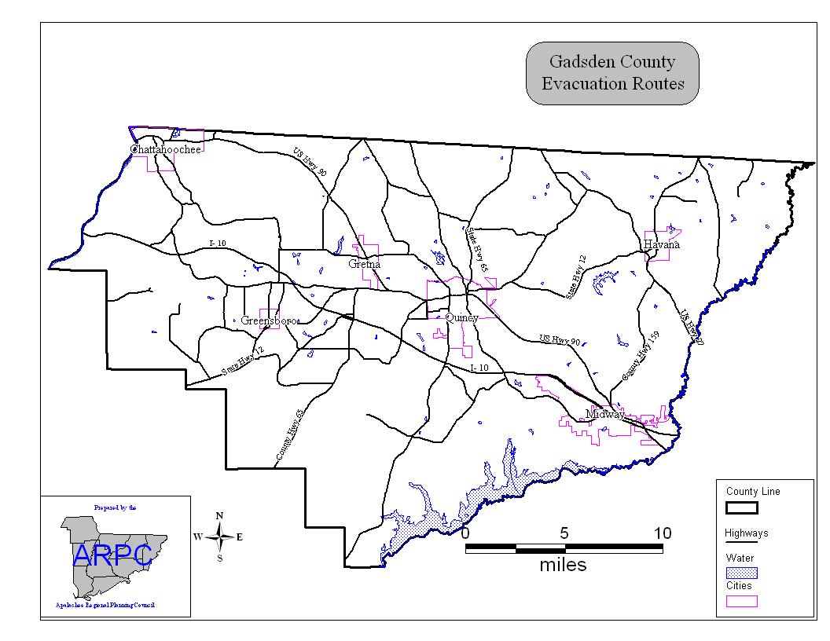
- Special Needs Population

- Registration

The Gadsden County EM Administrative Assistant is responsible for registering special needs individuals to ensure that they are provided the attention they require during disasters. There are approximately 350 special needs individuals registered in the County. The evacuation of the special needs population must be coordinated with the Disaster Service Office of the Capital Area Chapter of the American Red Cross.

- Transportation

The primary agency responsible for transporting special needs clients to the special needs shelter in Chattahoochee is the Gadsden County School Board. Additional transportation assistance is provided by Big Bend Transit. Gadsden County Emergency Medical Services will assist in transporting non-ambulatory special needs patients.

- Sheltering

The Capital Area Chapter of the American Red Cross (ARC) is responsible for staffing the special needs shelter. The special needs shelter for Gadsden County is located at the East Gadsden High School in Quincy.

- Mobile Home Population

Gadsden County has a mobile home population of approximately 16,467. Mobile home residents will be advised as to evacuation routes and the location of the nearest available safe shelter via radio and television announcements and the Capital Area Hurricane Survival Guide.

- Re-entry into Affected Areas

The Emergency Management Director or designee will authorize re-entry into an area after a determination has been made by the local law enforcement agency in conjunction with all appropriate agencies that the area is safe.

3. Sheltering

- Primary Agency for Sheltering

The Capital Area Chapter of the ARC is the primary agency responsible for coordinating sheltering in Gadsden County. The ARC is assisted in this task by the Gadsden County Emergency Management Department.

- Position Responsible for Authorizing the Opening of a Shelter

The EM Director or designee, after consulting with the Disaster Services Office of the ARC, is responsible for making the decision to open a shelter.

- Location of Shelters

There are identified 26 host/risk shelters throughout Gadsden County, Exhibit 1.26 indicates these locations. These shelters have a host capacity of 5,905 based on 40 square feet per shelter resident. If necessary, the amount of space allocated per person can be reduced to 20 square feet per person, doubling the shelter capacity.

Shelters in Gadsden County
Shelter Name | City | Shelter  Capacity | Classification
Chattahoochee Elementary | Chattahoochee | 250 | Risk/Host
Chattahoochee High School | Chattahoochee | 180 | Host
East Gadsden High School | Havana | 800 | Risk/Host
Havana Elementary School | Havana | 375 | Host
Greensboro High School | Greensboro | 275 | Host
Stewart Street Elementary School | Quincy | 250 | Host
Florida State Hospital | Chattahoochee | 250 | Host
Chattahoochee Presbyterian Church | Chattahoochee | 125 | Host
Friendship African Methodist Church | Chattahoochee | 200 | Host
Greensboro Elementary School | Greensboro | 200 | Host
Gretna Elementary School | Gretna | 300 | Host
Gretna City Hall | Gretna | 400 | Host
Carter-Parramore Academy | Quincy | 320 | Host
Havana Middle School | Havana | 290 | Risk/Host
St. Johns Elementary School | Quincy | 240 | Host
St. John AME Church | Quincy | 60 | Host
St. James AME Church | Quincy | 70 | Host
George W Munroe Elementary School | Quincy | 200 | Host
Quincy Recreational Center | Quincy | 100 | Host
James A. Shanks Middle School | Quincy | 290 | Host
Old Bethel AME Church | Quincy | 70 | Host
New Bethel AME Church | Quincy | 70 | Host
Midway Magnet Elementary School | Quincy | 350 | Host
Mormon Church | Quincy | 40 | Host
West Gadsden High School | Greensboro | 275 | Host
Arnet Chapel AME Church | Quincy | 60 | Host
Gadsden Technical Institute | Quincy | 200 | Host
Source: Capital Area Chapter of the American Red Cross, Statewide Emergency Shelter Plan

- Shelter Staffing and Support

The Capital Area Chapter of the American Red Cross will provide shelter staffing and support with trained local volunteers. Additional volunteers are available throughout the Capital Area Chapter. Specific procedures for sheltering are in the shelter SOG.

Insert Exhibit 1.26: Shelter Map
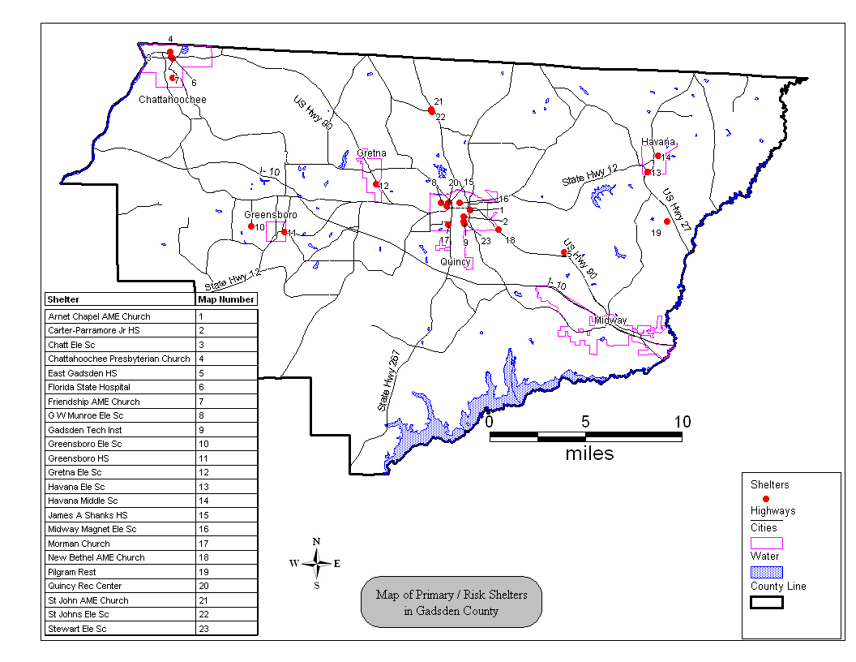
IV. FINANCIAL MANAGEMENT

- Gadsden County Clerk’s Office

1. Responsibilities

The Clerk of the Court’s Office is responsible for tracking all County finances, including those incurred during disasters. The Clerk's Office will follow established common accounting procedures, as described by current local, state, and federal laws, rules and regulations. The Clerk of the Court is the lead for financial management.

2. Accounting Procedures

The EM Department will work with the Clerk’s Office to ensure that proper procedures are followed regarding record collection for all expenditures for manpower and equipment associated with a disaster.

3. Financial Management Training Needs

The Clerk’s Office will determine financial management training needs and will coordinate all necessary training.

4. Tracking Costs During Activations

When it becomes necessary to activate due to an emergency, the Clerk of the Court, or his/her designee, will track all associated costs for County agencies for manpower, equipment, supplies, etc. Reimbursement may be made to those agencies that supply proper documentation. Extreme care and attention to detail will be taken throughout the emergency response period to maintain accurate logs, records and file copies of all expenditures (including personnel time sheets) in order to provide clear and reasonable accountability and justification for future reimbursement requests.

Gadsden County’s municipalities are each responsible for tracking their own costs during emergencies.

5. Record Keeping

The process of record keeping noted in paragraph IV.A.4 also applies to any mutual aid rendered by cities in Gadsden County, under the Statewide Mutual Aid Agreement and the Emergency Management Assistance Compact. Accurate and complete records for all expenses (including personnel time sheets and detailed description of equipment provided and duration used) will be required in order to seek reimbursement for eligible expenses.
6. Purchases

Any purchases made during a disaster must be pre-approved by the EM Director or his designee. The Gadsden County Sheriff’s Office has established accounts with many of the providers of services needed during disasters. Goods and services required by the EM Department may be direct billed to the County or may be paid for with a credit card issued to the EM Coordinator.

7. Maintenance of Financial Records

Maintenance of financial records will be the joint responsibility of the Clerk's Office and the Emergency Management Department.

8. Funding Sources for Emergency Management Activities

There are a number of funding sources available to provide financial assistance to the County for all phases of emergency management. These sources, and the required local roles and responsibilities, are discussed in the Gadsden County Local Mitigation Strategy.

9. Emergency Management Funding Agreements in Place

The primary funding agreements in place include Emergency Management, Preparedness and Assistance base grant funds, federal Emergency Management Performance Grant funds and funding for the update of hazard analyses of facilities storing large quantities of hazardous materials. Gadsden County has also received funding for projects through the Hazard Mitigation Grant Program (HMGP) to provide shutters for schools and other critical facilities.

- County’s Financial Relationship with Municipalities

Municipalities within Gadsden County are responsible for managing their own finances. This is true during disasters as well as day-to-day operations. Each local government has the responsibility to maintain accurate records of expenditures incurred during the response to and recovery from a disaster.

V. REFERENCES AND AUTHORITIES

A. County Responsibilities as Defined by Florida Statutes, Chapter 252

- Safeguarding the life and property of all citizens.

- Maintaining the Emergency Management Office.

- Appointing an emergency management director, who shall coordinate the activities, services, and programs for emergency management and maintain liaison with the State DEM and other local emergency management agencies.

- Performing emergency management functions within the County as well as outside the County as needed.

- Appropriating and expending funds as necessary to fulfill responsibilities delegated under FS Chapter 252.

- Establishing one or more emergency operations centers.

- Making available all County resources for emergency operations.

- Declaring a local state of emergency for up to seven (7) days, extendible in 72 hours increments.

- Invoking mutual aid agreements using DEM as liaison.

B. Additional Florida Statutes Applicable to Local EM Programs

- Florida Statutes, Chapter 110, State Government Part IV, Volunteers

- Florida Statutes, Chapter 125, County Government, Part VI, Volunteers

- Florida Statutes, Chapter 163, Intergovernmental Programs, Part II County and Municipal Planning and Land Development Regulation

- Florida Statutes, Chapter 215.555, Florida Hurricane Catastrophe Fund

- Florida Statutes, Chapter 252, Emergency Management, Part I - General Provisions

- Florida Statutes, Chapter 252, Emergency Management, Part II - Florida Hazards Materials Emergency Response and Community Right-To-Know Act

- Florida Statutes, Chapter 376, Pollutant Discharge and Prevention and Removal

- Florida Statutes, Chapter 380, Land and Water Management

- Florida Statutes, Chapter 501.160, Rental or Sale of Essential Commodities During a Declared State of Emergency

- Florida Statutes, Chapter 768.13, Good Samaritan Act

- Florida Statutes, Chapter 943, Domestic Security

C. Florida Administrative Code

- Rule 27P-2, State of Florida Comprehensive Emergency Management Plan Criteria

- Rule 27P-6, Review of Local Emergency Management Plans

- Rule 27P-11, Funding Formula for Emergency Management Assistance Funds

- Rule 27P-14, Hazardous Materials

- Rule 27P-19, Base Funding for County Emergency Management Agencies, Emergency Management Competitive Grant Program and Municipal Competitive Grant Program Rule

D. Plans and Procedures Related to the CEMP

- Gadsden County Local Mitigation Strategy

- Gadsden County Critical Facility Inventory

- Emergency Operations Center Standard Operating Guidelines

- Notification and Warning Standard Operating Guidelines

- Mass Care Standard Operating Guidelines

- Damage Assessment Standard Operating Guidelines

- Debris Management Standard Operating Guidelines

- Disaster Recovery Center Standard Operating Guidelines

- Public Assistance Program Standard Operating Guidelines

- Resource and Financial Management Policies and Procedures for Emergency Management

- State Emergency Response Team (SERT) Standard Operating Procedure

- State of Florida Comprehensive Emergency Management Plan

- Public Law 106-390, Disaster Mitigation Act of 2000

- Statewide Mutual Aid Reimbursement Documentation Information

- Local Agency Standard Operating Guidelines

- Gadsden County Hazardous Materials Facility Analyses

E. Local Administrative Rules and Procedures Governing Emergency Management

The standard administrative rules, policies and guidelines promulgated by the Gadsden County Board of County Commissioners apply to emergency management activities. No other local codes are applicable.

F. Other Supporting Documents

1. Gadsden County EM Notification Directory

2. Gadsden County Emergency Management Five-Year Strategic Plan

G. Mutual Aid Agreements

Statewide Mutual Aid Agreement

H. NIMS Compliance References

1. Homeland Security Presidential Directive (HSPD)-5
2. Homeland Security Presidential Directive (HSPD)-7
3. Homeland Security Presidential Directive (HSPD)-8
4. National Response Framework (NRF)
5. National Incident Management System (NIMS)
6. National Incident Management Capability Assessment Tool (NIMCAST)

VI. ACRONYMS

ALF Assisted Living Facility
ARC American Red Cross
ARES Amateur Radio Emergency Service
CAP Civil Air Patrol
CEMP Comprehensive Emergency Management Plan
CERT Community Emergency Response Team
CIC Citizens Information Center
DAT Damage Assessment Teams
DMAT Disaster Medical Assistance Team
DMORT Disaster Mortuary Response Team
EAS Emergency Alert System
ECO Emergency Coordinating Officer
EMAC Emergency Management Assistance Compact
EMPA Emergency Management Preparedness and Assistance Trust Fund
EMS Emergency Medical Services
EOC Emergency Operations Center
ESF Emergency Support Function
FDEM Florida Division of Emergency Management
FOG Field Operations Guide
HURREVAC Hurricane Evacuation Tracking Program
IC Incident Commander
IC/UC Incident Command or Unified Command
ICP Incident Command Post
ICS Incident Command System
JFO Joint Field Office
JIC Joint Information Center
LEPC Local Emergency Planning Committee
LSA Logistical Staging Area
MACS Multi-Agency Coordination System
NFIP National Flood Insurance Program
NIMS National Incident Management System
NRF National Response Framework f/k/a Federal Response Plan
PIO Public Information Officer
POD Points of Distribution
RC Regional Coordinator (DEM)
SCO State Coordinating Officer
SEOC State Emergency Operations Center
SITREP Situation Report
SMAA Statewide Mutual Aid Agreement
SOG Standard Operating Guidelines
SW) State Warning Office
UC Unified Command
USAR Urban Search and Rescue

VII. TERMS AND DEFINITIONS

Activation Level III, Monitoring Activation: This level will be implemented whenever Emergency Management (EM) receives notice of an incident, which may escalate to threaten public safety.

Activation Level II, Hazard Specific Activation: This level may be implemented by EMD, or upon request of the Incident Commander (or their designees). Only those ESF’s impacted by the hazard or involved in the response will be represented at the EOC.

Activation Level I, Full County Activation: This level may be implemented for a major event. All Sections, ESF’s, the Policy Group, the Liaison Group and Support Staff will be staffed 24 hours per day.

Amateur Radio Emergency Service (ARES): This is a volunteer group of amateur radio operators who may be activated by Emergency Management or ESF-2 to provide communications support in times of emergency.

Area Command (Unified Area Command): An organization established (1) to oversee the management of multiple incidents that are each being handled by an ICS organization or (2) to oversee the management of large or multiple incidents to which several Incident Management Teams have been assigned. Area Command has the responsibility to set overall strategy and priorities, allocate critical resources according to priorities, ensure that incidents are properly managed, and ensure that objectives are met and strategies followed. Area Command becomes Unified Area Command when incidents are multi-jurisdictional. Area Command may be established at an emergency operations center facility or at some location other than an incident command post.

Assistant: Title for subordinates of principal Command Staff positions. The title indicates a level of technical capability, qualifications, and responsibility subordinate to the primary positions. Assistants may also be assigned to unit leaders.

Branch: The organizational level having functional or geographical responsibility for major aspects of incident operations. A branch is organizationally situated between the section and the division or group in the Operations Section, and between the section and units in the Logistics Section. Branches are identified by the use of Roman numerals or by functional area.

Burn Sites: The open areas identified for the collection and open burning of disaster caused debris.

Catastrophic Disaster: An incident that overwhelms the capability of local and state resources and requires federal assistance and/or resources. Examples include a Category four or five hurricane.

Chain of Command: A series of command, control, executive, or management positions in hierarchical order of authority.
Check-In: The process through which resources first report to an incident. Check-in locations include the incident command post, Resources Unit, incident base, camps, staging areas, or directly on the site.

Chief: The ICS title for individuals responsible for management of functional sections: Operations, Planning, Logistics, Finance/Administration, and Intelligence (if established as a separate section).

Clearance Time: The clearance time is the mobilization, travel and queuing delay time and is based on the number of people required to evacuate, the number of vehicles that may be used, the suitability of the roads (capacity, elevation, location, etc.) and then any special evacuation considerations such as medical facilities and people with special needs.

Coastal High Hazard Area: Area as defined in F.S. 252, as the Category 1 hurricane evacuation area.

Comfort Stations: Stations are managed under ESF 6 to provide basic emergency services to victims such as food and water, health and first aid treatment, relief supplies, information and temporary refuge.

Command: The act of directing, ordering, or controlling by virtue of explicit statutory, regulatory, or delegated authority.

Command Staff: In an incident management organization, the Command Staff consists of the Incident Command and the special staff positions of Public Information Officer, Safety Officer, Liaison Officer, and other positions as required, who report directly to the Incident Commander. They may have an assistant or assistants, as needed.

Comprehensive Emergency Management Plan (CEMP): A plant that establishes uniform policy and procedures for the effective coordination of preparedness, response, recovery and mitigation activities related to a wide variety of natural and technological disasters. See Rule 9G-6 F.A.C. and Chapter 252 F.S.

COG Plan: Continuity of Government Plan establishing policy and guidance to ensure the continuation and line of succession for governmental functions.

COOP Plan: Continuity of Operations Plan establishing policy and guidance to ensure the execution of an organization’s mission essential functions in any event that requires the relocation of selected personnel and functions to an alternate facility.

County Warning Point: The location that the State will contact in case of an emergency. The primary County Warning Point is located in the County Sheriff’s Communications Division. It is staffed 24 hrs a day.

Critical Facility: This is a "structure" from which essential services and functions for health and human welfare, continuation of public safety actions and/or disaster recovery are performed or provided.

Damage Assessment: An estimation of damages made after a disaster has occurred which serves as the basis of the Governor’s request to the President for a declaration of Emergency or Major Disaster.

Deputy: A fully qualified individual who, in the absence of a superior, can be delegated the authority to manage a functional operation or perform a specific task. In some cases, a deputy can act as relief for a superior and, therefore, must be fully qualified in the position. Deputies can be assigned to the Incident Commander, General Staff, and Branch Directors.

Disaster Recovery Center (DRC): Center locations set-up for victims to apply for state and federal assistance programs for which they may be eligible. DRC’s do not usually provide direct services.

Division: The partition of an incident into geographical areas of operation. Divisions are established when the number of resources exceeds the manageable span of control of the Operations Chief. A division is located within the ICS organization between the branch and resources in the Operations Section.

Emergency: Absent a Presidential declared emergency, any incident(s), human-caused or natural, that requires responsive action to protect life or property. Under the Robert T. Stafford Disaster Relief and Emergency Assistance Act, an emergency means any occasion or instance for which, in the determination of the President, Federal assistance is needed to supplement State and local efforts and capabilities to save lives and to protect property and public health and safety, or to lessen or avert the threat of a catastrophe in any part of the United States.

Emergency Alert System (EAS): System replaces the Emergency Broadcasting System as the primary relay and notification system for delivering emergency information to residents through the broadcast media.

Emergency Operations Center (EOC): The physical location at which the coordination of information and resources to support domestic incident management activities normally takes place. An EOC may be a temporary facility or may be located in a more central or permanently established facility, perhaps at a higher level of organization within a jurisdiction. EOCs may be organized by major functional disciplines (e.g., fire, law enforcement, and medical services), by jurisdiction (e.g., Federal, State, regional, county, city, tribal), or some combination thereof.

Emergency Operations Plan: The "steady-state" plan maintained by various jurisdictional levels for responding to a wide variety of potential hazards. In Florida this plan is referred to as the CEMP.

Emergency Public Information: Information that is disseminated primarily in anticipation of an emergency or during an emergency. In addition to providing situational information to the public, it also frequently provides directive actions required to be taken by the general public.

Emergency Response: An incident is in progress or has occurred requiring local resources only. This includes vehicle accidents, fires, utility losses, etc.

Emergency Satellite Communications System (ESATCOM): This is the 24 hour dedicated satellite communications link between the State Emergency Operations Center and the 67 counties, 6 local weather forecast offices and 14 key local media outlets.

Emergency Support Function (ESF): A functional area of response activity established to facilitate the delivery of county and/or state assistance required during the immediate response and recovery phases. The concept uses a functional approach to group response actions, which are most likely to be needed, under seventeen Emergency Support Functions (ESF’s).

Evacuation Levels: Areas pre-designated by local emergency management officials as requiring evacuation for hazard vulnerability. Hurricane evacuation levels are normally based on salt water, river and lake flooding from storm surge as determined by surge model data.

Event: A planned, none emergency activity. ICS can be used as the management system for a wide range of events, e.g., parades, concerts, or sporting events.

Federal Coordinating Officer (FCO): The senior federal official appointed in accordance with the provisions of the Stafford Act to coordinate the overall federal response and recovery activities.

Federal Emergency Management Agency (FEMA): The lead agency for federal emergency management planning and response.

Field Hospitals/Emergency Clinics: Those sites where Disaster Medical Assistance Teams (DMAT’s) or local hospitals/physicians may set-up temporary emergency clinics to provide emergency medical care in the disaster area. The locations are established to supplement the pre-existing medical network.

Full-scale Exercise: An exercise intended to evaluate the operational capability of emergency management systems in an interactive manner over a substantial period of time. It involves the testing of a major portion of the basic elements existing within emergency operations plans and organizations in a stress environment. This type of exercise includes the mobilization of personnel and resources and the actual movement of emergency workers, equipment and resources required to demonstrate coordination and response capability.

Function: Refers to the five major activities in ICS: Command, Operations, Planning, Logistics and Finance/Administration. The term is also used when describing the activity involved, e.g., the planning function. A sixth function, Intelligence, may be established, if required, to meet incident management needs.

Functional Exercise: An exercise intended to test or evaluate the capability of an individual function or complex activity within a function. It is applicable where the activity is capable of being effectively evaluated in isolation from other emergency management activity.

General Staff: A group of incident management personnel organized according to function and reporting to the Incident Commander. The General Staff normally consists of the Operations Section Chief, Planning Section Chief, Logistics Section Chief, and Finance/Administration Section Chief.

Group: Established to divide the incident management structure into functional areas of operation. Groups are composed of resources assembled to perform a special function not necessarily within a single geographic division. Groups, when activated, are located between branches and resources in the Operations Section. (See Division.)

Hazard Mitigation: The process of potential improvements that would reduce or remove the hazard vulnerability.

Hazardous Material Sites: Sites pre-identified in the County Hazardous Materials Vulnerability Analysis as containing extremely hazardous substances.

Hazard Vulnerability Analysis (HVA): The process of collecting information about local hazards, risks to those hazards, the extent to which they threaten local populations and the vulnerability the hazards present. An HVA may include mitigation measures required to abate the hazards, priority/goal settings, and funding mechanisms available for hazard reduction.

Hurricane: Tropical weather system characterized by pronounced rotary circulation with a constant minimum wind speed of 74 miles per hour (64 knots) that is usually accompanied by rain, thunder and lightning and storm surge. Hurricanes often spawn tornadoes.

Hurricane Eye: The roughly circular area of comparatively light winds and fair weather at the center of a hurricane. Eyes are usually 25-30 miles in diameter. The area around the eye is called the wall cloud. * Do not go outdoors while the eye is passing, the intensity of the storm will reoccur in minutes.

Hurricane Landfall: The point and time during which the eye of the hurricane passes over the shoreline. After passage of the calm eye, hurricane winds begin again with the same intensity as before but from the opposite direction.

Hurricane Season: The six-month period from June 1st through November 30th considered the hurricane season.

Hurricane Vulnerability Zone: Zone defined as the category three hurricane evacuation zone.

Hurricane Warning: Warning issued by the National Hurricane Center 24 hours before hurricane conditions (winds greater than 74 mph) are expected. If the hurricane path changes quickly, the warning may be issued 10 to 18 hours or less, before the storm makes landfall. A warning will also identify where dangerously high water and waves are forecast even though winds may be less than hurricane force.

Hurricane Watch: Watch issued by the National Hurricane Center when a hurricane threatens, the watch covers a specified area and time period. A hurricane watch indicates hurricane conditions are possible, usually within 24 - 36 hours. When a watch is issued, listen for advisories and be prepared to take action if advised to do so.

Incident: An occurrence or event, natural or human-caused that requires an emergency response to protect life or property. Incidents can, for example, include major disasters, emergencies, terrorist attacks, terrorist threats, wildland and urban fires, floods, hazardous materials spills, nuclear accidents, aircraft accidents, earthquakes, hurricanes, tornadoes, tropical storms, war-related disasters, public health and medical emergencies, and other occurrences requiring an emergency response.

Incident Action Plan: An oral or written plan containing general objectives reflecting the overall strategy for managing an incident. It may include the identification of operational resources and assignments. It may also include attachments that provide direction and important information for management of the incident during one or more operational periods.

Incident Command Post (ICP): The field location at which the primary tactical-level, on-scene incident command functions are performed. The ICP may be collocated with the incident base or other incident facilities and is normally identified by a green rotating or flashing light.

Incident Command System (ICS): A standardized on-scene emergency management construct specifically designed to provide for the adoption of an integrated organizational structure that reflects the complexity and demands of single or multiple incidents, without being hindered by jurisdictional boundaries. ICS is the combination of facilities, equipment, personnel, procedures, and communications operating within a common organizational structure, designed to aid in the management of resources during incidents. It is used for all kinds of emergencies and is applicable to small as well as large and complex incidents. ICS is used by various jurisdictions and functional agencies, both public and private, to organize field-level incident management operations.

Incident Commander (IC): The individual responsible for all incident activities, including the development of strategies and tactics and the ordering and the release of resources. The IC has overall authority and responsibility for conducting incident operations and is responsible for the management of all incident operations at the incident site.

Incident Management System (IMS): Organization framework for managing an incident or event. A combination of facilities, equipment, personnel, procedures and communications operating within a common organizational structure. with responsibility for management of assigned resources to effectively direct and control the response to an incident. It is intended to expand as the situation requires larger resources, without requiring new, reorganized command structure. Incident Command System is a form of IMS.

Incident Management Team (IMT): The IC and appropriate Command and General Staff personnel assigned to an incident.

Incident Objectives: Statements of guidance and direction necessary for selecting appropriate strategy(s) and the tactical direction of resources. Incident objectives are based on realistic expectations of what can be accomplished have been effectively deployed. Incident objectives must be achievable and measurable, yet flexible enough to allow strategic and tactical alternatives.

Individual Assistance: Assistance provided to individuals and private business in the form of grants and low interest loans by the Federal government.

Intelligence Officer: The intelligence officer is responsible for managing internal information, intelligence, and operational security requirements supporting incident management activities. These may include information security and operational security activities, as well as the complex task of ensuring that sensitive information of all types (e.g., classified information, law enforcement sensitive information, proprietary information, or export-controlled information) is handled in a way that not only safeguards the information, but also ensures that it gets to those who need access to it to perform their missions effectively and safely.

Joint Field Office (JFO): Office established in or near the designated area to support State and Federal response and recovery operations. The JFO houses the Federal Coordinating Officer (FCO) and the Emergency Response Team (ERT), and where possible, the State Coordinating Officer (SCO) and support staff.

Joint Information Center (JIC): A facility established to coordinate all incident-related public information activities. It is the central point of contact for all news media at the scene of the incident. Public information officials from all participating agencies should collocate at the JIC.

Joint Information System (JIS): Integrates incident information and public affairs into a cohesive organization designed to provide consistent, coordinated, timely information during crisis or incident operations. The mission of the JIS is to provide a structure and system for developing and delivering coordinated interagency messages; developing, recommending, and executing public information plans and strategies on behalf of the IC; advising the IC concerning public affairs issues that could affect a response effort; and controlling rumors and inaccurate information that could undermine public confidence in the emergency response effort.

Jurisdiction: A range or sphere of authority. Public agencies have jurisdiction at an incident related to their legal responsibilities and authority. Jurisdictional authority at an incident can be political or geographical (e.g., city, county, tribal, State, or Federal boundary lines) or functional (e.g., law enforcement, public health).

Landing Zone: Any designated location where a helicopter can safely take off and land. Some heliports may be used for loading of supplies, equipment or personnel.
Liaison Officer: A member of the Command Staff responsible for coordinating with representatives from cooperating and assisting agencies.

Local Government: A county, municipality, city, town, township, local public authority, school district, special district, intrastate district, council of governments (regardless of whether the council of governments is incorporated as a nonprofit corporation under State law), regional or interstate government entity, or agency or instrumentality of a local government; an Indian tribe or authorized tribal organization, or in Alaska a Native village or Alaska Regional Native Corporation; a rural community, unincorporated town or village, or other public entity. See Section 2 (10), Homeland Security Act of 2002, Pub. L. 107-296, 116 Stat. 2135 (2002).

Local State of Emergency: Declared whenever an evacuation is ordered by the Board of County Commissioners, the County Administrator or the Emergency Management Director. Normal community functions are severely disrupted and the county government requires outside assistance as deemed necessary by the Policy Group.

Logistical Staging Area (LSA): Area established by the State to receive, classify and account for emergency relief supplies solicited by the State and which will be distributed to county points of distribution (POD) based upon request and priority.

Logistics: Providing resources and other services to support incident management. Logistics Section: The section responsible for providing facilities, services, and material support for the incident.

Long-Term Recovery Phase: Phase that begins within a week of the disaster impact and may continue for years. Long-term recovery activities include: on-going human service delivery; rebuilding the economy, infrastructure, and homes; implementation of hazard mitigation projects, and funds recovery.

Major Disaster: As defined under the Robert T. Stafford Disaster Relief and Emergency Assistance Act (42 U.S.C. 5122), a major disaster is any natural catastrophe (including any hurricane, tornado, storm, high water, wind-driven water, tidal wave, tsunami, earthquake, volcanic eruption, landslide, mudslide, snowstorm, or drought), or, regardless of cause, any fire, flood, or explosion, in any part of the United States, which in the determination of the President causes damage of sufficient severity and magnitude to warrant major disaster assistance under this Act to supplement the efforts and available resources of States, tribes, local governments, and disaster relief organizations in alleviating the damage, loss, hardship, or suffering caused thereby.

Management by Objective: A management approach that involves a four-step process for achieving the incident goal. The Management by Objectives approach includes the following: establishing overarching objectives; developing and issuing assignments, plans, procedures, and protocols; establishing specific, measurable objectives for various incident management functional activities and directing efforts to fulfill them, in support of defined strategic objectives; and documenting results to measure performance and facilitate corrective action.

Mandatory Evacuation Order: Order that will be issued when there is a definite threat to life safety. Failure to comply with a mandatory evacuation order is a misdemeanor under Florida Statute 252.50.

Mass Feeding Sites: Temporary locations strategically placed near the disaster area where residents can go for a meal. Food may also be distributed to take home from these locations.

Minor Disaster: An incident that is likely to be within the response capability of local government and to result in only minimal need for State and Federal assistance.

Mitigation: The activities designed to reduce or eliminate risks to persons or property or to lessen the actual or potential effects or consequences of an incident. Mitigation measures may be implemented prior to, during, or after an incident. Mitigation measures are often informed by lessons learned from prior incidents. Mitigation involves ongoing actions to reduce exposure to, probability of, or potential loss from hazards. Measures may include zoning and building codes, floodplain buyouts, and analysis of hazard- related data to determine where it is safe to build or locate temporary facilities. Mitigation can include efforts to educate governments, businesses, and the public on measures they can take to reduce loss and injury.

Multi-agency Coordination Entity –A multi-agency coordination entity functions within a broader multi-agency coordination system. It may establish the priorities among incidents and associated resource allocations, de-conflict agency policies, and provide strategic guidance and direction to support incident management activities.

Multi-agency Coordination Systems – Multi-agency coordination systems provide the architecture to support coordination for incident prioritization, critical resource allocation, communications systems integration, and information coordination. The components of multi-agency coordination systems include facilities, equipment, emergency operation centers (EOCs), specific multi-agency coordination entities, personnel, procedures, and communications. These systems assist agencies and organizations to fully integrate the subsystems of the NIMS.

Multi-jurisdictional Incident – An incident requiring action from multiple agencies that each have jurisdiction to manage certain aspects of an incident. In ICS, these incidents will be managed under Unified Command.

Mutual Aid Agreement – Written agreement between agencies and/or jurisdictions that they will assist one another on request, by furnishing personnel, equipment, and/or expertise in a specified manner.

NFIP Flood Zones – Areas designated by the National Flood Insurance Program (NFIP) as being vulnerable to velocity and/or freshwater flooding based on the 100 and 500 year storms. Flood zones include inland areas.

National Disaster Medical System – A cooperative, asset-sharing partnership between the Department of Health and Human Services, the Department of Veterans Affairs, the Department of Homeland Security, and the Department of Defense. NDMS provides resources for meeting the continuity of care and mental health services requirements of the Emergency Support Function 8 in the Federal Response Plan.

National Incident Management System – A system mandated by HSPD-5 that provides a consistent nationwide approach for Federal, State, local, and tribal governments; the private-sector, and nongovernmental organizations to work effectively and efficiently together to prepare for, respond to, and recover from domestic incidents, regardless of cause, size, or complexity. To provide for interoperability and compatibility among Federal, State, local, and tribal capabilities, the NIMS includes a core set of concepts, principles, and terminology. HSPD-5 identifies these as the ICS; multiagency coordination systems; training; identification and management of resources (including systems for classifying types of resources); qualification and certification; and the collection, tracking, and reporting of incident information and incident resources. National Response

Nongovernmental Organization – An entity with an association that is based on interests of its members, individuals, or institutions and that is not created by a government, but may work cooperatively with government. Such organizations serve a public purpose, not a private benefit. Examples of NGOs include faith-based charity organizations and the American Red Cross.

Operational Period – The time scheduled for executing a given set of operation actions, as specified in the Incident Action Plan. Operational periods can be of various lengths, although usually not over 24 hours.

Operations Section – The section responsible for all tactical incident operations. In ICS, it normally includes subordinate branches, divisions, and/or groups.

Personnel Accountability – The ability to account for the location and welfare of incident personnel. It is accomplished when supervisors ensure that ICS principles and processes are functional and that personnel are working within established incident management guidelines.

Planning Meeting: A meeting held as needed prior to and throughout the duration of an incident to select specific strategies and tactics for incident control operations and for service and support planning. For larger incidents, the planning meeting is a major element in the development of the Incident Action Plan (IAP).

Planning Section: Responsible for the collection, evaluation, and dissemination of operational information related to the incident, and for the preparation and documentation of the IAP. This section also maintains information on the current and forecasted situation and on the status of resources assigned to the incident.

Points of Distribution (PODS): Locations where donations of food, water and other supplies received from the State Resource Center will be given directly to residents. Distribution Points may be located in parking lots or open fields in the disaster area, as close to victims as possible.

Post-Impact Response Phase – Phase begins once the disaster occurs and may continue for up to a month. This phase includes the following activities: communications, public information, hazard abatement, search and rescue (SAR), emergency medical service delivery, temporary shelter, impact/needs assessment, security, re-entry, traffic control, debris clearance, resource distribution and volunteer management.

Pre-Impact Response Phase – Phase is the monitoring and preparedness phase before disaster strikes. This phase may begin up to 72 hours before an incident (hurricane) and continues until the disaster occurs. This phase includes hazard monitoring/tracking, incident notification, Emergency Operations Center (EOC) activation, public information and warning, evacuation, sheltering (in-place, risk and host) and communications and coordination activities.

Preliminary Damage Assessment (PDA) – This assessment begins immediately after disaster impact and determines whether more detailed damage assessments are necessary and identifies those areas where further efforts should be concentrated.

Public Assistance - The reimbursement and emergency assistance provided to State and local governments and private non-profit entities from the Federal government.

Public Information Officer (PIO) – A member of the Command Staff responsible for interfacing with the public and media or with other agencies with incident-related information requirements.

Preparedness: The range of deliberate, critical tasks and activities necessary to build, sustain, and improve the operational capability to prevent, protect against, respond to, and recover from domestic incidents. Preparedness is a continuous process. Preparedness involves efforts at all levels of government and between government and private-sector and nongovernmental organizations to identify threats, determine vulnerabilities, and identify required resources. Within the NIMS, preparedness is operationally focused on establishing guidelines, protocols, and standards for planning, training and exercises, personnel qualification and certification, equipment certification, and publication management.

Preparedness Organizations: The groups that provide interagency coordination for domestic incident management activities in a non-emergency context. Preparedness organizations can include all agencies with a role in incident management, for prevention, preparedness, response, or recovery activities. They represent a wide variety of committees, planning groups, and other organizations that meet and coordinate to ensure the proper level of planning, training, equipping, and other preparedness requirements within a jurisdiction or area.

Prevention: Actions to avoid an incident or to intervene to stop an incident from occurring. Prevention involves actions to protect lives and property. It involves applying intelligence and other information to a range of activities that may include such countermeasures as deterrence operations; heightened inspections; improved surveillance and security operations; investigations to determine the full nature and source of the threat; public health and agricultural surveillance and testing processes; immunizations, isolation, or quarantine; and, as appropriate, specific law enforcement operations aimed at deterring, preempting, interdicting, or disrupting illegal activity and apprehending potential perpetrators and bringing them to justice.

Primary Agency – Agency leading each ESF as its primary agency, which has been selected based on its authorities, resources and capabilities.

Private Sector: Organizations and entities that are not part of any governmental structure. It includes for-profit and not-for-profit organizations, formal and informal structures, commerce and industry, and private voluntary organizations (PVO). Processes: Systems of operations that incorporate standardized procedures, methodologies, and functions necessary to provide resources effectively and efficiently. These include resource typing, resource ordering and tracking, and coordination.

Project Worksheet (PW) - Form completed by state and federal teams to document eligible public assistance expenses.

Reception Area: This refers to a location separate from staging areas, where resources report in for processing and out-processing. Reception Areas provide accountability, security, situational awareness briefings, safety awareness, distribution of IAPs, supplies and equipment, feeding, and bed down.

Recommended Evacuation – Order that will be issued when it is determined that the hazard may cause discomfort to residents and minimal damage to property but it is not expected to threaten life safety.

Recovery: The development, coordination, and execution of service- and site-restoration plans; the reconstitution of government operations and services; individual, private- sector, nongovernmental, and public-assistance programs to provide housing and to promote restoration;
long-term care and treatment of affected persons; additional measures for social, political, environmental, and economic restoration; evaluation of the incident to identify lessons learned; post incident reporting; and development of initiatives to mitigate the effects of future incidents.

Recovery Plan: A plan developed by a State, local, or tribal jurisdiction with assistance from responding Federal agencies to restore the affected area.

Resource: Personnel and major items of equipment, supplies, and facilities available or potentially available for assignment to incident operations and for which status is maintained. Resources are described by kind and type and may be used in operational support or supervisory capacities at an incident or at an EOC.

Resource Management: Efficient incident management requires a system for identifying available resources at all jurisdictional levels to enable timely and unimpeded access to resources needed to prepare for, respond to, or recover from an incident. Resource management under the NIMS includes mutual-aid agreements; the use of special Federal, State, local, and tribal teams; and resource mobilization protocols.

Resource Staging Centers (RSC) –The location in the county where supply donations and volunteers will be received from the Regional Recovery Center for redistribution to County distribution points. RSC’s may be used as distribution points. Supplies may also be warehoused at the RSC if space permits.
Resources Unit: Functional unit within the Planning Section responsible for recording the status of resources committed to the incident. This unit also evaluates resources currently committed to the incident, the effects additional responding resources will have on the incident, and anticipated resource needs.

Response: Activities that address the short-term, direct effects of an incident. Response includes immediate actions to save lives, protect property, and meet basic human needs. Response also includes the execution of emergency operations plans and of mitigation activities designed to limit the loss of life, personal injury, property damage, and other unfavorable outcomes. As indicated by the situation, response activities include applying intelligence and other information to lessen the effects or consequences of an incident; increased security operations; continuing investigations into nature and source of the threat; ongoing public health and agricultural surveillance and testing processes; immunizations, isolation, or quarantine; and specific law enforcement operations aimed at preempting, interdicting, or disrupting illegal activity, and apprehending actual perpetrators and bringing them to justice.

Regional Recovery Centers (RRC) – The location where all resources from outside of the area will be directed for redistribution to County RSC as requested. The RRC is also known by many other names.

Safety Officer: A member of the Command Staff responsible for monitoring and assessing safety hazards or unsafe situations and for developing measures for ensuring personnel safety.

Saffir/Simpson Hurricane Scale – Scale used by the National Hurricane Center to provide a continuing assessment of the potential for wind and storm surge damage.

Section: The organizational level having responsibility for a major functional area of incident management, e.g., Operations, Planning, Logistics, Finance/Administration, and Intelligence (if established). The section is organizationally situated between the branch and the Incident Command.
Security Checkpoints - Those locations where all traffic will be stopped to check for identification in order to determine access to the disaster area.

Shelter - Temporary emergency shelters activated prior to a disaster impact, operated during the disaster and closed as soon as residents can be returned to their homes or relocated to long-term shelters or temporary housing areas.

Shelter-In-Place – Recommendation that means residents will be advised to remain in their homes with the windows closed and all open air circulation systems turned off. Sheltering-in-place should not be implemented when the sheltering duration is expected to exceed two hours. If it is determined that sheltering will exceed two hours, it is best to evacuate.

Short-Term Recovery Phase – Phase that may begin immediately after the disaster impact and continues for approximately six months. The Short-Term Recovery Phase includes the implementation of individual assistance programs through Disaster Recovery Centers (DRC’s) and Red Cross Service Centers and public assistance programs through damage survey teams and forms completion. Other short-term activities include: long-term sheltering (hotels/motels, mobile homes, tent cities, etc.), on-going human service delivery, debris removal, contractor licensing, permitting and inspections.

Situation Report (SITREP) – The summary of events, actions taken and anticipated in response to an emergency. SITREP’s will be issued as needed. As a guide SITREP’s should be issued daily during a monitoring activation and at least twice per day during a full activation.

Span of Control: The number of individuals a supervisor is responsible for usually expressed as the ratio of supervisors to individuals. (Under the NIMS, an appropriate span of control is between 1:3 and 1:7.)

Special Needs Program - The program through which impaired persons who need special assistance in times of emergency, are registered, evacuated and sheltered.

Staging Area - Location established where resources can be placed while awaiting a tactical assignment. The Operations Section manages Staging Areas.

Standard Operating Guideline (SOG) - A ready and continuous reference to those roles, relationships and procedures within an organization which are used for the accomplishment of broad or specialized functions which augment the CEMP. They are developed by primary and support agencies as needed to implement their responsibilities under the ESF Annexes.

State Emergency Response Team (SERT) – Team that coordinates State of Florida response and recovery functions through 17 Emergency Support Functions.

SERT Liaison Officer (SERTLO) – Officer that provides the communication and coordination link between the SERT in the State Emergency Operations Center and the County EOC Team.

State of Emergency – Order issued by the Governor.

Statewide Mutual Aid Agreement for Disaster Response and Recovery (SMAA) - The chief agreement between counties and the State for providing mutual aid assistance, which details request and reimbursement procedures.

State Warning Point (SWP) - The 24-hour answering point in the State Emergency Operations Center for reports of unusual emergencies and/or requests for State assistance.

Storm Surge - The dome of seawater, often 50 miles across, that is pushed by hurricane winds and sweeps across the coastline inundating the land with water potentially many feet above normal high tide. The ocean level rises as a hurricane approaches, peaking where the eye strikes land, and gradually subsiding after the hurricane passes. Storm surge, also known as tidal flooding, has historically been responsible for nine out of ten hurricane deaths.

Storm Surge Model Data - Model based on the SLOSH (Sea Lake and Overland Surges from Hurricanes) model that shows those areas expected to be inundated with salt water flooding during a hurricane. All county evacuation levels are based on storm surge model data.

Strike Team: A set number of resources of the same kind and type that have an established minimum number of personnel.

Support Agency – Agency in support for one or more ESF’s based on their resources and capabilities to support the functional area.

Tabletop Exercise - An activity in which exercise participants are presented with simulated emergency situations without time constraints. It is intended to evaluate plans and procedures and to resolve questions of coordination and assignments of responsibility. Tabletop exercises are not concerned with time pressures, stress or actual simulation of specific events.

Task Force: Any combination of resources assembled to support a specific mission or operational need. All resource elements within a Task Force must have common communications and a designated leader.

Technical Assistance: Support provided to State, local, and tribal jurisdictions when they have the resources but lack the complete knowledge and skills needed to perform a required activity (such as mobile-home park design and hazardous material assessments).

Temporary Housing Areas – Area where tents or mobile home units may be set-up for residents to live before they are able to return to their own homes or until they find a new home.

Terrorism: Under the Homeland Security Act of 2002, terrorism is defined as activity that involves an act dangerous to human life or potentially destructive of critical infrastructure or key resources and is a violation of the criminal laws of the United States or of any State or other subdivision of the United States in which it occurs and is intended to intimidate or coerce the civilian population or influence a government or affect the conduct of a government by mass destruction, assassination, or kidnapping. See Section 2 (15), Homeland Security Act of 2002, Pub. L. 107-296, 116 Stat. 2135 (2002).

Tornado Warning - Warning issued when a tornado funnel is sighted or indicated by radar. You should take shelter immediately. Because tornadoes can form and move quickly, there may not be time for a warning. That is why it is important to stay alert during severe storms.

Tornado Watch - Watch issued when weather conditions are favorable to the formation of tornadoes, for example during severe thunderstorms. During a Tornado Watch, keep an eye on the weather and be prepared to take shelter immediately if conditions worsen.

Tribal: Any Indian tribe, band, nation, or other organized group or community, including any Alaskan Native Village as defined in or established pursuant to the Alaskan Native Claims Settlement Act (85 stat. 688) [43 U.S.C.A. and 1601 et seq.], that is recognized as eligible for the special programs and services provided by the United States to Indians because of their status as Indians.

Tropical Storm - Area of low pressure with a definite eye and counter clockwise winds of 39-74 mph. A tropical storm may strengthen to hurricane force in a short period of time.
Tropical Storm Warnings – Warning issued by the National Hurricane Center when winds of 55-73 mph (48-63 knots) are expected. If a hurricane is expected to strike a coastal area, separate tropical storm warnings may precede hurricane warnings.

Traffic Control Points - Key intersections on the road network where staff may be needed to physically control traffic flow.

Type: A classification of resources in the ICS that refers to capability. Type 1 is generally considered to be more capable than Types 2, 3, or 4, respectively, because of size; power; capacity; or, in the case of incident management teams, experience and qualifications.

Unified Area Command: A Unified Area Command is established when incidents under an Area Command are multi-jurisdictional. (See Area Command.)

Unified Command - An application of ICS used when there is more than one agency with incident jurisdiction or when incidents cross political jurisdictions. Agencies work together through the designated members of the UC, often the senior person from agencies and/or disciplines participating in the UC, to establish a common set of objectives and strategies and a single IAP.

Unit: The organizational element having functional responsibility for a specific incident planning, logistics, or finance/administration activity.

Unity of Command: The concept by which each person within an organization reports to one and only one designated person. The purpose of unity of command is to ensure unity of effort under one responsible commander for every objective.

Volunteer: For purposes of the NIMS, a volunteer is any individual accepted to perform services by the lead agency, which has authority to accept volunteer services, when the individual performs services without promise, expectation, or receipt of compensation for services performed. See, e.g., 16 U.S.C. 742f(c) and 29 CFR 553.101.

Voluntary Evacuation – Order that will be issued when it is determined that the hazard may cause discomfort to residents and minimal damage to property but it is not expected to threaten life safety.

